Lyne Kawadri
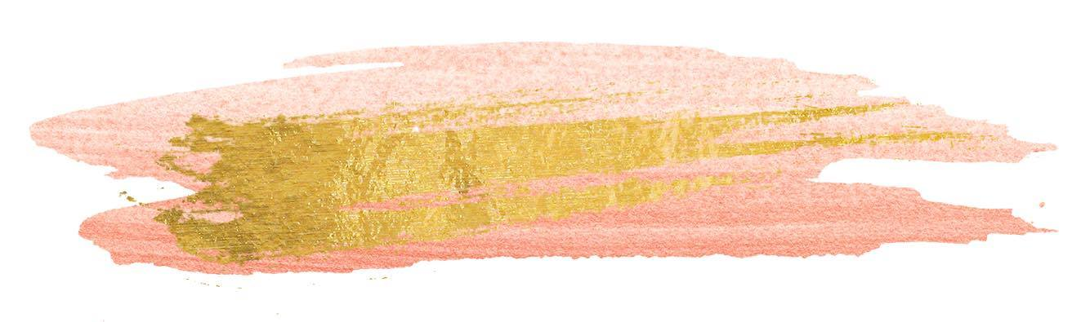
LyneKawadri@gmail.com
Lak27@mail.aub.edu
Phone number: +961 71 383586
Professional Experience
March 15th, 2018 ongoing
Lebanese Weddings Beirut, Lebanon
Head of Development
- Handle social media accounts and content development on Instagram (stories and posts)
- Direct and supervise the live coverage of weddings and events on social media
- Develop media strategies for clients, wedding planners and designers to develop an artistic approach and style
- Write articles and plan content for the upcoming website ( Style, Beauty, Haute Couture and Weddings)

January, 2018 To March 10th,2018
Stepfeed, Beirut, Lebanon
Editorial Intern
- Write and create articles in media, news and culture
- Assist in day to day tasks at the office, setting up meetings and planning upcoming content.
- Assist the editor and the social media manager in content research
- https://stepfeed.com/a/lyne-kawadri

September, 2017 Nature Conservation Center, AUB, Lebanon, Beirut
To December, 2017 Marketing Assistant
- Prepared proposals, articles, reports and presentations
- Performed miscellaneous job-related duties as assigned
- Assisted with preparation of all educational and training workshops and evaluation strategies
October, 2013 American University of Beirut Medical Center, Beirut, Lebanon
To May,2017 Tutoring University Students
- Aided and tutored students in media, English, cultural studies and psychology courses.

November, 2015
To December,2015 Beirut Digital Space Platform at the Annual Beirut Book Fair, Beirut, Lebanon
Coordinator and Director
- Maintained the smooth run of the platform from employees to the venue itself.
- Coordinated publicity and talked to journalists and the press
- Created and applied the daily schedules of the event including the Speakers

June, 2014 The Fan Park for Fifa World Cup, VI Management, Lebanon, Beirut
To July, 2014 Event Manager
- Managed all aspects of the event, from venue and table reservations
- Organized the facility and details with décor, entertainment and promotional material
- Supervised over 30 employees that reported back to me

October, 2013 GOMAC & GOFIT clinics, Lebanon, Beirut
To May, 2014 Medical coordinator and receptionist
- Coordinated appointments with clients and answered phone calls
- Ensured smooth communication of the patients’ needs to the doctor
- Assessed and evaluated the progress of the health plan of patients

March, 2012 Souria Al Ghad, Damascus, Syria
To April, 2012 Radio Host
- Prepared the material and content for the Radio
- Announce and read the material prepared recorded before air time.
June, 2009 Manific Event Planning, Damascus, Syria
To December, 2011 Promoter and Assistant-Manager
- Assisted in all tasks with the manager in successful fashion shows of Lebanese Designers such as Robert Abi Nader
- Managed and supervised the launching cocktail party of Zuhair Murad Villas x Seven Invest Developers.

Education

2013 – 2017 Bachelor of Arts in Media Studies and Communication – Minor in Creative writing, Minor in Nursing Science, American University of Beirut/ Lebanon

-2013 Diploma in Event Planning, Online, Beirut / Lebanon
1996-2012 French Baccalaureate, Économiques et Sociales, Lycee Charles De Gaulles , Damascus / Syria
Volunteer Work
2013-2014 Hand in Hand for Syria Charity, AUB club – Public relations and social media manager
2009-2012 Drop of Milk Association – Fundraising and Public Relations Manager (organized fundraising events and responded to press and journalists)
2005-2010 Canadian Terry Fox foundation- Run to find a cure for cancer
2006-2010 Syrian National Scout- Member

Personal skills

- Ability to work in a team structure and very sociable
- Organized, Punctual and Time efficient
- Ability to multi-task and manage various elements.
- Social media and media literate
- Creative writer and content editor
- Research skills
- Microsoft office and Audacity (Sound bite editing) program
- International mindset and multicultural
- Very knowledgeable and a fast learner
- Ability to entertain people
- broad knowledge of fashion industry trends, beauty, make up and luxury.
- Ability to socially communicate with people inside and
outside the organization
Languages:
English: Native
French: Native
Arabic: Native
Spanish: Intermediate

Activities & Passions

- Reading Books and articles
- Writing, blogging and journalism
- Fashion and Beauty
- Event planning and social media
- Horseback riding
- Music and playlist curation
- Les Mills program gym classes
- Travel, exploring and multicultural experiences
- Art and real estate enthusiast

