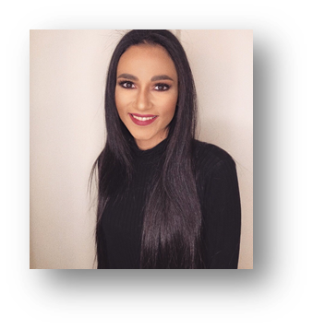

Ghida Allam




Baccalaureate in Economics and Sociology
New century school, choeifat 2003 – 2016
Rank 17 in Lebanon
EXPERIENCE
Bachelor in business administration/ Double concentration: Accounting, Finance
American university of Beirut, Beirut 2017 – 2020
Gpa: 3.43/4 - 82.6/100
EDUCATION
Junior seeking an internship
Email:
ghidaallam9@gmail.com
Phone:
+96170678241

Address:
Choeifat,Baabda, Lebanon
linkedin:
linkedin.com/in/ghida allam
A current university junior seeking an apprenticeship in the business industry. Eventual career goal is to become a fully-qualified and experienced Financier and accountant with the longer-term aspiration of moving into Business law.
R E S U M E O B JE CT I V E
CONTACT


SKILLS

Languages: English- Arabic
Computer skills: Excel-Visio- PowerPoint
Interests: club memberships- community involvement- group work- Track and field

Member and organizer
Redcross, AUB, Beirut / September 2018 - Present
- Supply blood and platelets in the blood donation information center
- Organize activities for the orphans for the orphanage subcommittee


EXTRACURRICULAR ACTIVITIES
- Volunteer at Bassma Organization, Badaro / July 2018 – Present
- Volunteer at AUB Unicef club / September 2018 – Present
- Organized the 3rd Annual Robotics competition at the Lebanese University
- Participated in the “Moubarat el Oloum” held by the National association for science and research

