EXPERIENCE
RESTAURANT MANAGER – LA2MOUCHE - Lebanon
Since March 2018
- Establishment of a business plan
- Building a budget
- In charge of the recruitments (chef and employee)
- External communication : menu, flyer, social media pages
- Salesman : cashier and clients hosting

EDUCATION
LICENSE – BUSINESS MANAGEMENT
Beirut Arab University (BAU) - 2018
- Management, Information system management, Accounting, Finance, etc.
BACCALAUREATE – ECONOMIC SCIENCES
Ajyal High School – 2013

SKILLS
LANGUAGES
Arabic | Native
English | Full professional efficiency
French | Intermediate
SOFTWARES – Full proficiency
ICDL (International Computer Driving License)
Word
Excel
PowerPoint
Access

Management
Strategy
Marketing

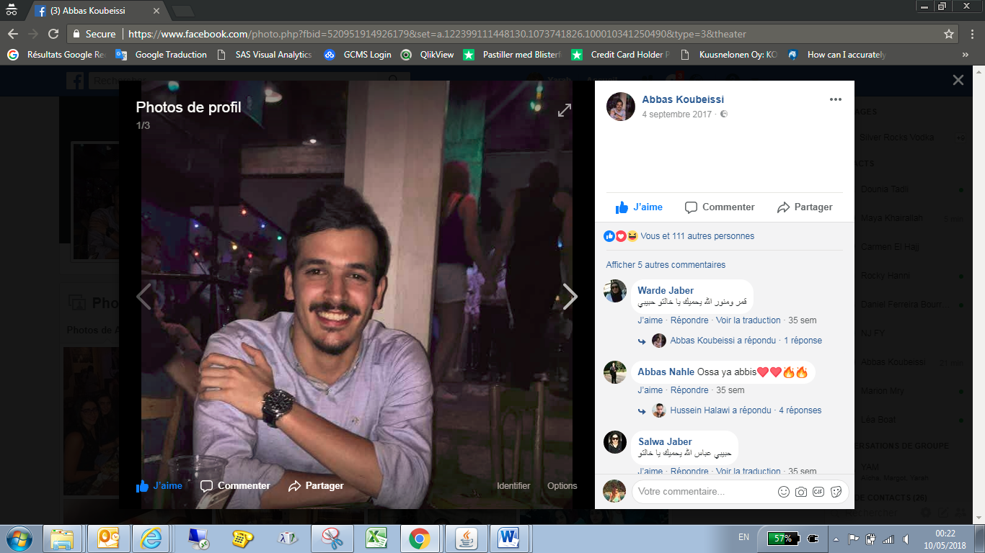
PROFILE
Recently graduated in Business Management, I am looking for a job as salesman, accountant or business manager.

CONTACT
abbas.k94@outlook.com
00 961 3754985
Nabatieh (Lebanon)

Nationality : Lebanese
Date of Birth : 26 / 10 / 1994

PERSONAL INTERESTS

Football 
Ping – pong 
Swimming 

ABBAS KOUBEISSI

