Curriculum Vitae
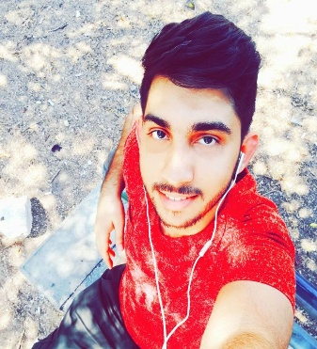
Personal Details:
Name and Surname: Mohamad Hamza Shahabi
Address: Lebanon, Aley, Baalchmay, Abo Faraj bldg, 1st floor.
Telephone: +961 3 369 409
Email: shahabimohamad6@gmail.com
Birth date: 17.1.1993
Sex: Male
Nationality: Lebanese
Marital Status: Single
Education:
- Art, Science and Technology University in Lebanon - AUL (Beirut-Cola): B.A in Journalism -Communication Arts (Graduated 2016-2017).
- Shakib Erslan (Verdun) Secondary School (Official Bac2 Certificate in SE).
Professional Experience:
- Worked at Al–Ibdaa institution for two years, as an Arabic and English teacher for primary school students, (2012-2013).
- Volunteer at Al-Ibdaa institution in helping Syrian Refugees, (2013-2014).
- Worked at AUL Radio for two years, offer programs, cover events, interviews (2015-2016).
- Working at Quds TV as a Sound Technician, for four years (2013-2017).
- Writer at "مدونات الجزيرة" , (http://blogs.aljazeera.net/shahabimohamad) (2016 – 2017).
- Writer at “مدونات العربي الجديد”, (https://www.alaraby.co.uk/author/2017/5/1/%D9%85%D8%AD%D9%85%D8%AF-%D8%B4%D9%87%D8%A7%D8%A8%D9%8A) (2017).
- Training course at Lebanon TV, presented by d. Nada AlHout (2016).
- Training at Lebanon Debate as an Editor (2016).
- Training course for Al-Jazeera Ambassadors Initiative in Turkey, in “Meeting the Press”, presented by Jasim Al-Azzawi, (2016).
- Working at Roua Library, till now (part time).
- Training at Quds TV as an Editor and Reporter, (2016-2017).
- Training course for Quds TV, in “Tv Reporter”, (2017).
- Working at Quds Tv as an editor and reporter (2017-2018).
- Training course at Quds Tv, in تركيز الصوت وفن الإلقاء, (2018).
Expert on Social Media:
Facebook: shahabimohamad
Twitter: Mohmad_Shahabi
Instagram: mohamadshahabi37
Snapchat: shahabimohamad6
Additional Skills:
- Very good in writing and using word document, excel.
- Archiving and data entry.
Languages:
Arabic (Mother Tongue), English (Advanced Level), French (Basic Knowledge), Turkish (Basic Knowledge).
Hobbies:
- Reading, writing, music.
- Watching movies and series.
- Hiking, traveling, swimming.
- Follow up News from all around the world.
About Me:
- Honest and respectful with people, and need their respect and honesty.
- Hard worker and always seeking development.
- I do my best work when I’m under pressure.
- Team Work: I have the ability to help my team work for the benefit of the organization.
- Communication (personal, face to face and by writing).

