Yakouta Al-Ahmad
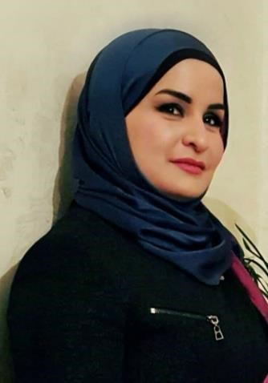

Nationality: Lebanese
Date of birth: 29/09/1983 Marital Status: Single.
Home Address: Lebanon, Beirut, Kaskas, Arab Street, Arab & Itani Building, 3rd floor, A.

Cell Phone 0096170\456 184

Email hyacente@gmail.com ya2outelshar2@hotmail.com

Facebook https://www.facebook.com/yakout.dandashi
Twitter: https://twitter.com/YakootDandashy

YouTube: https://www.youtube.com/channel/UCay9orZpUjnE5zQ4_86IB5Q/vide os
https://www.youtube.com/watch?v=ljKDMhkXJC0

Objective
Interested in opportunities in TV-presenting (news and programs), reporting, producing, editing, mentoring and training, and proofreading.

Profile
Energetic, resourceful and creative communicator. I enjoy team work and adapt easily to pressing situations. I maintain focus in demanding work environments and deliver high quality output.

Education
2018_2019: Master.1 in Political Sciences/International Relations(ongoing) , Lebanese University, al-Hadat- Beirut.
2015-2018: B.A in Political Sciences, Lebanese University, al-Hadat- Beirut.
2008: LT2 degree (Management & Organization) = Bac+5, Technical Institute of Tripoli, Lebanon,

Experience
- Since 01/11/2017: Arabic proofreader (currently), Al Quds Satellite Channel, Beirut, Lebanon.
- 2017: News Anchor, bulletin producer, editor, proof reader, news team trainer at Nour al Arab TV
-2013/2017: News Anchor, bulletin producer, editor, Arabic proof reader, news team trainer at: al Thabat TV Satellite Chanel, Lebanon.
-2011/2014: Admin, Senior-Editor, writer, and proofreader at www.alwassat.com Electronic-Press.
- 2010\2014: Books editor and proofreader for publishers and writers.
-2009: Internet and Public Relations Employer at the Touristic Site of Jeita Grotto, Mapas – Lebanon.
-2008: Achieved a Management Consultant Study concerning the Humane Resources and the Reorganization at “Jeita Grotto Touristic Site, Mapas - Lebanon”.
-2005: Achieved a case study about the international standard organization “ISO” concerning quality consequences across the world “ISO”, at El.Youssef Medical Center”, Halba- Lebanon.
- Since 2002: have typed and designed several books before publishing, in Arabic, French, and English.

-Poet, I published my first book “Shobhatou Hob”, by Dar al Nahda, Beirut, 2016.
- Main member in Shahrayad cultural assembling (music, poetry, and painting) in Hamra, Beirut, Lebanon.
-Writer: Writing a true story right now, and a private research.

Training
- 2014: Participate in several workshops anti-corruption.
- 2013: News presenting training at the UCMT Media Center, Beirut.
-2013: Workshop: Active Citizens, British Council.
-2010: a private training concerning TV. Presenting Tools and skills with Mr. Ali Shoqueir.
- 2007: courses at the: “Shabab Al Azm Wa Saada” Center, Tripoli, Lebanon:
  - Leadership.
  - English communication skills.
-2005: Secretary training at the “National Centre of Technical and Professional Studies”, Halba-akkar/Lebanon.

Language Skills
Fluent Arabic with an excellent writing and narration skills, very good English and French.

Computer Skills
EDIUS videos editing program, News-room system, WSP: News bar updates and breaking news updates, Microsoft Word and Excel, Internet and web search.

