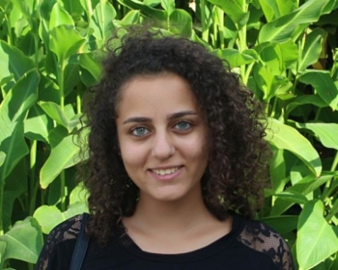
Curriculum Vitae
Rama Kasamany

PERSONAL STATEMENT

I became interested in teaching after realizing how much I had benefited from excellent and passionate teachers. They exuded a real sense of enthusiasm for learning which inspires me to pass on that passion. I'm Highly motivated and innovative biologist. My objective is to extend my
educational capabilities and to teach through a growth oriented position. Passionate about learning new scientific and educational skills. Enthusiastic team player adept at providing leadership while also learning from fellow team members.

PERSONAL DETAILS

Name : Rama Naami Kasamany
Date of Birth : 25/10/1996
Marital status : Engaged
Citizenship : Lebanese
Telephone : (+961) 71034475
Email : ramakasamany@gmail.com

EDUCATION

• 2018 - Present:
Modern University for Business & Science (MUBS)-Lebanon
• Teaching Diploma in Science for Secondary to be awarded in Summer 2019.
• 2017 - Present:
Beirut Arab University (BAU) - Faculty of Science - Lebanon.
• M.Sc. in Biology to be awarded in summer 2020
• 2014 - 2017:
Lebanese International University (LIU) - Faculty of Science - Lebanon.
• B.Sc. in Biology

EXPERIENCE

• 2018 - Present: (on leave)
Science teacher for grade 1 and 7- Baakline Official School-Lebanon
• 2017-2018
Library Assistant - Beirut Arab University-Lebanon
• 2014 - 2018:
Biology &Chemistry Private Tutor

OTHER SKILLS AND INTEREST

• Languages: Fluent in English . Mother Tongue is Arabic.
• IT Skills: Advanced user of Microsoft Office Suite, including Excel, PowerPoint and Word.
• Interests: Reading, travelling.
- Volunteering: Volunteer in Lebanese Red Cross (Youth Department) for 8 years
Head of Center 2017-2018

PROFESSIONAL REFEREES

Available upon Request

