Nour Saleh  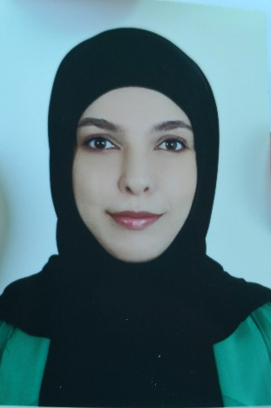 |  | Mechanic street-Jemous  Hadath – Mont Lebanon  phone: +961 71 37 47 72  nour.k.saleh96@gmail.com
EDUCATION | La Sagesse University (ULS)  Bachelor of Business Administration (Major Management)  2016 - present  American University of Culture & Education  Freshman in Science  2014-2015  Borj International College  High School - American System  2013-2014
PROFESSIONAL  CAREER | AIESEC, Vice President  2017 - present  Team management  - International Collaboration  - Targeted Recruitment  - Exchange Positioning  - Planning  - Monitor Delivery  - Providing Financial Sustainability  - Leadership Development  - Managing Learning Environment  - Team Management  Handmade shop, Beirut  2016 - 2017  Sales Representative and Assistant Manager  - Inventory and Finance Control.  - Took care of Customer service.  - Shop and Shopfront design
ADDITIONAL SKILLS AND INTERSTS  Volunteering  Skills  Interpersonal skills  Accomplishments  Extra Curriculum  Activities | NGOs: AIESEC  Projects: 26 Letters Project  Language - Fluent in Arabic, French, English  Computer Skills - Microsoft Office softwares, Access Software  Management – Problem Sensitivity and Solving – Team Motivation – Communication – Customer Service – Team Building – Team Leadership – Active Listening – Engaging People – Training – Time Efficient  Communication skills workshop (soft and hard)  Fashion Design Course Level 1  Emotional intelligence workshop  Public speaking Workshop  Ecolearn summit (Financial literacy conference)  Personal Interests – Personal Growth, Sewing and Knitting, Reading, Adventures.
References available upon request

