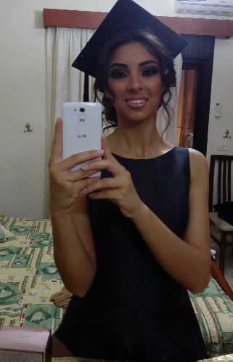
Lily Fakhoury

- OCT 12/ 1998

- Zouk el khrab rue saidet el maghara, Dbayeh, Lebanon
- Lilyfakhoury98@gmail.com instagram.com/lilyfakhoury/
- +96176807455
- +9614543103

Dedicated and focused young woman, who excels at prioritizing, completing multiple tasks simultaneously, and following through to achieve project goals. Able to grow professional relationships with clients and colleagues at all organizational levels. Answers a high volume of incoming calls while handling in-person inquiries from clients and colleagues. Flexible and hardworking with strong drive to succeed.

Experience

2018-08 -> 2018-11 Babel 5 stars Restaurant-Dbayeh-Zaituna Bay
Guest Realtions Agent
- Administer guest reservations and space management in coordination with the Maitre D'Hotel
- Reservation in order to optimize the seating capacity of the restaurant
- Warmly and graciously greet all guests upon arrival and departure and manage the waiting list for a walk-ins to ensure that all guests are received properly
- Escort guests through the restaurant and accommodate special seating requests for guests whenever possible to help in building a satisfying experience
- Prepare daily recap on capacity and turnover to be noted in the log book and logs in data in all identified sheets so that the data can be used in future planning - Handle guest complaints professionally according to standard procedures and report immediately to Maitre D'Hotel Reservation to find the best solution - Implement the quality and food safety management system as per the requirements of applicable national statutory and regulatory requirements as well as international standards and guidelines
2016-09 -> 2018-01 AZADEA RETAIL GROUP – DECATHLON
Sales / Cashier / Customer Service Assistant
LeMall Dbayeh (Store)
        - Deliver a high standard customer service, provide with the necessary support, promote gif cards, up-sell and cross-sell products and services
        - Arrange and replenish on a continuous basis the shop shelves and ensure that the shop floor and shelves are kept clean and tidy at all times
        - Handle the cash register systems and sales transactions
        - Keep track and handle all store schedules, staff leaves, customer requests, deliveries management

Education

2001-> 2016 Rosary sisters school graduate
Cornet El Hamra 2001-2016

● Obtained a 77% on SAT score

2016-> Current Lebanese University
Jal el dib
● Second Year accomplishing a bachelor degree in Law

Languages

Arabic speaking, reading, writing ● Native language
English speaking, reading, writing ● Fluently
French speaking, reading, writing ● Fluently (School system)


Interests_______________________________________________
- Social medias marketing
- Phylosophy and human behariour
- International politics and relationships
- Leadership and communications.

*References are available upon request*

