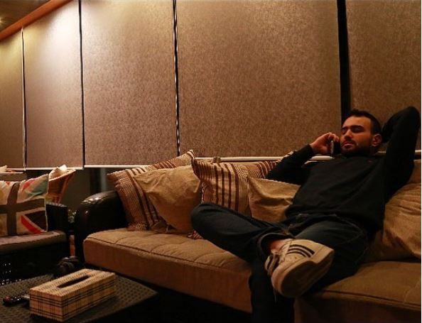

Alex Sarkis Raffi Momjian

Date of Birth: September 15th 1995

Nationality: Lebanese

Marital Status: Single

Resident of: Zalka Saideh Street –Beirut: Lebanon
Gender: Male
Tel: 70/541466
Email: alexmomjian@gmail.com

Objective:
I’m looking for a challenging position where I can grow both professionally and personally.
I’m a quick learner and looking for increasing your company’s high value.

education:

1998-2009: Holy Cross Armenian Catholic School Zalka (Grade 9) Brevet

2010-2015: Accounting & Information Baccalaureate degree at Montana Institute

2017-2019: Business Administration in Accounting at Arab Open University with an Award GPA of 3.5

PROFESSIONAL experience:
August 2015-March 2016: Worked for Mady & Co for Audit As an Accountant Intern
Where I have acquired Knowledge in
1.Data Entry
2 Bank Statements Reconciliation
3 Analyze Daily Business Transactions for Companies, Pharmacies Gas Stations

Year 2016: Worked for Mady & Co for Audit As a Junior Accountant Where I have acquired Knowledge in

1.CNSS Transactions And Payroll
2.Assisting in Vat , R3 R5 R7 Ministry of Finance Declations
3 Assisting in the Preparation of the Balance Sheet of Some Companies
4 Reconcile Bank Statements
5 Monthly Closings

Year 2017- Present Working For Joseph B Amatoury SARL (Amatoury 114) as Head of Accounting

1.Reviewing Supplier/Client Accounts
2.Process Payments for Suppliers
3.Preparing all Declarations Such as VAT , Top 10 Supplier/Clients, R3 R5 R7 ,
4 Reconcile the Statements of the Bank Accounts
5 Preparing the Cash Flow
6 Balance Sheet and P&L
7 Review the Payroll and Posting it
8 Reviewing CNSS

WorkShop Attendance & TRAINING Certificates

Move forward International & fast forward academy
Consolidated Financial Statements

Move forward International & fast forward academy

Financial Statement Analysis where I gained knowledge in process of reviewing and analyzing a company's financial statements to make better economic decisions.

Orientation workshop foundation for personal success

Volunteering Experience

At the Age of 13 for about 8 Months
Scout member for Armenian General Benevolent Movement (AGBU) At the Demirjian Center

At the Age of 22 for 3 Months
Teaching First Communion Students in their English and Armenian Religion Studies for their
Program

At the Age of 23
Participated in the First aid Course at the Lebanese Red Cross Centre

Skills

Wide Knowledge in Microsoft Excel Alongside Word and the other Office

Programs.

Fast Learner and Confidential user in any Accounting Software Program
(New Focus,Orient,Omega,Socrat ‘Automated Information Management System’)

LANGUAGES, PERSONALITY:

Languages: Personality:
- Integrity
- Ethics
- Organized
- Teamwork
- Recognition
- Communication
- Continuous Improvement
- Interpersonal skills.
- Great logical analysis.

- Arabic
- Armenian
- English
Some French

