CURRICULUM VITAE
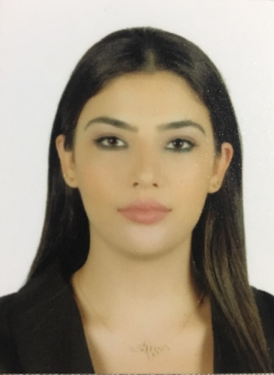
Name: Sabah Wattar
Address: Beirut,jnah
Mobile: 0096176652005
Email: sabah.wattar11@gmail.com
PERSONAL INFORMATION:
Marital status: Single
Nationality: Palestinian
Place and date of birth: Beirut, 1995
Gender: Female
EDUCATION:
Bachelor in Journalism at Lebanese international university.(graduated 2017)
Studied banking and finance (1 year)
Certificate from Cisco for represent an "I Do Project 2"
Certificate from Lebanese Ministry of Economy for representing ADD about consumer production.
Certificate from aljadeed tv.
WORK EXPERIENCE:
- News anchor at (Lana plus tv 2019)
- Presenter for Khbar w Srar program (Lana tv 2018)
- Presenter and Reporter at Al Minbar Tv (2017)
-News editor
-News anchor
-Presenter for takareer dowalya program
-Presenter for MESHWAR program
- Stage at AlJadeed News Room (2016)
- Training at PALESTINE Tv
- Stage at National News Agency (2016)
- LIU Community Volunteers
- Photographer at Studio Al Sultan
- Photographer at Tedxliubeirut
Languages
Arabic and English
Computer Skills
Microsoft word
Excell
Power point
Adope Premier
Fruity Loops
References : Upon request .

