GHIDA HAJJAR
LEBANESE
26/6/1997
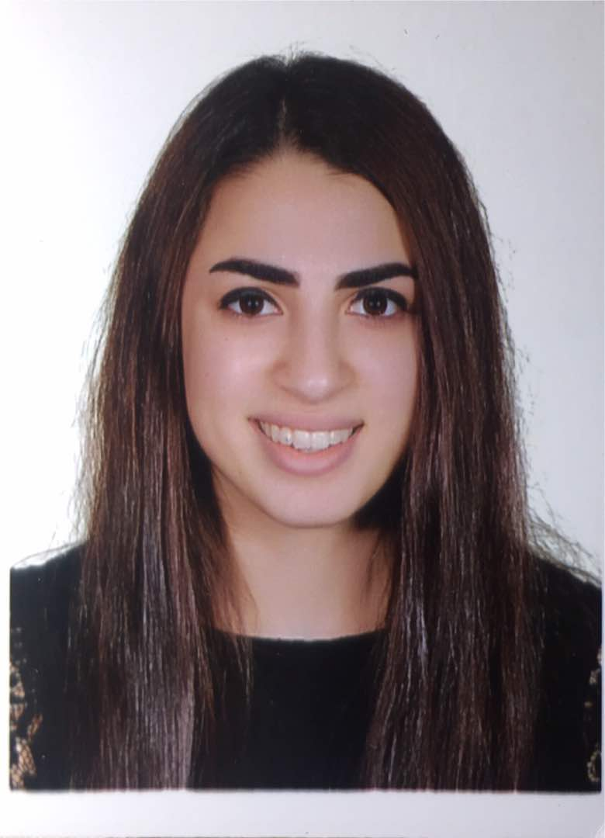
OBJECTIVE
Gaining an adequate experience in business marketing and sales to be qualified for a successful future career

EDUCATION
- Beirut Arab University
  - Business Marketing 2016 - 2018
3rd year student

- Omar Faroukh Public High School “Lebanon, Beirut” 2013-2016

EXPERIENCE
- Sales at Zara 2/6/2017-26/3/2018
- Scouts Group Leader “كشاف المستقبل-شحيم” 2011 – 2014
- Private Tutor 2016-2016
- Participant at Model United Nations LAU 2013-2014
- Call center agent at Zaatar W Zeitt 2017-2018

- Volunteering experience:

- Volunteering at Donner sang compter 2016-2017
- Volunteering at Makassed 2015-2016
- Volunteering at BAU Activities 2016-2017

Hobbies:
Hip hop dancer, yoga, gym, public relations, football, drawing, painting, hiking.
KEY SKILLS
- Language skills:
- Arabic: Native
- English: Fluent
- Computer skills:
- Technical proficiency in Microsoft Word, Microsoft Excel, and Microsoft Access ,IC3.
- Personal skills:
  - Proactive, quick learner, adaptable, and a team worker
  - Active on Social Media
  - Customer service

- Communication skills
Friendliness, open-mindedness, confidence, empathy, and respect.
CONTACT INFORMATION
E. ghida-hajjar@outlook.com
T. +96181662463

REFERENCES
Available upon request

