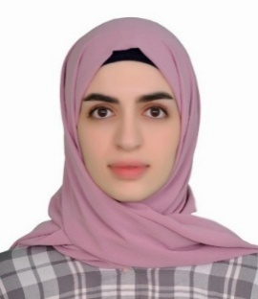

Zeinab Wissam Abbas

          - Date of birth:22/7/1997

            - Address: Hadath - EL JAMOUS Street

Mobile: 71 59 44 83

e-mail: zeinab.abbas898@gmail.com

EPersonal Profile

- Enthusiastic, energetic and adaptable I have considerable experience in working with people and having studied alongside full-time work, have a proven willingness to learn and work hard.

Possess interpersonal communication skills and the ability to interpret and define client needs through interviewing and information gathering processes.

Education

“Lebanese university” : CERTIFICATE AT BUSSINESS MANAGEMENT , had been graduated at 2018 , from Lebanese university , faculty of economic and Business Administration .

Experience

.

- From 20-4-2018 till 20-4-2019 : worked in the department of management at KAROUT MALL .

- From 15-2-2017 till 10-3-2018 : worked as a manager at KAROUT TRADING CENTER a commerical foundation.

- Successfully completed an internship at FNB BANK (FIRST NATIONAL BANK) during July 2017,showing good communication skills , teamworks and flexibility .

- During 2015 : - “BETTY gift shop”.
Sales management, I take responsibility for coordinating and organising the shop and working .
account program

- Giving private lectures for school’s students in Science (physics-chemistry-biology) , Math and English for 3 years .

Additional information

- Computer proficiencies: Active inspire ,Windows, M/S office (word, Excel, Power point, Access)
- 2015 -2016: Accomplished the “English language course”

Communication and Management:

Sociable, Cooperative, Disciplined, Organized,

Completely adapted and interacts well to teamwork conditions.

LANGUAGES

NAME Proficiency

Arabic fluent

English fluent

Hobbies and interests

Hiking, photography , and reading .

