Aya Samer Chaar

- Personal information:
-Email : aya-chaar@hotmail.com
-Mobile : 03/ 48 80 81
-Address: Beirut, Corniche El Mazraa

- Education:
- 2014 – 2018 (July): American University of Science & Technology (Business Management with Emphasis in Human Resources) Honor List – AUST
- January 31,2018: Letter of Recommendation from the Chairperson as a Recognition of My Academic High Achievements.

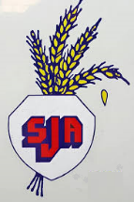
- 2009 - 2014: Ecole Notre Dame (Lebanese official BACC II in Life Science).

- 1998 – 2008 : École des Soeurs de Saint Joseph de l’Apparition - Beyrouth.

- Work Experience:

- HR Recruitment Officer at Al Makassed NGO (Education, HealthCare & Social Services) Jan/02/2019 - Present
- Job Posting Advertisements
- Prepare Job Descriptions
- Interview Candidates, Screen, Review Applications, Evaluate Applicant’s Skills, Check Eligibility & Make Recommendations regarding Applicant’s Qualifications & Short-Listing.
- Participate in careers and Job Fairs
- Filing Process & Data Management
- Conduct Exit Interviews

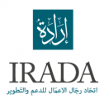
- Experience During Studies :
- Internship at Irada Khoubourat NGO in the Human Resources Department Nov/13/2018 – Dec/13/2018

- Interviewing Candidates
- Screening CVs
- Job Posting
- Shadowing HR manager in career guidance sessions
- Assist in data base development

- Internship at Rolex Lebanon in the Marketing Department. (128 Hours of Training) March/26/2018 – April/30/2018
- Conduct Research On Clients Profile Using Different Social Media Platforms
- Customer Relationship Management – CRM
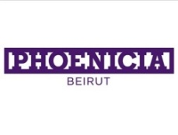
- Assist & Train the Sales Advisors Team to improve Data Quality


- Internship at Phoenicia Intercontinental Beirut in the Human Resources Management Department (Talent Resourcing, Personnel, Learning and Development). ( 216 Hours of Training ) November/13/2017 – January/12/2018
- Interviews Shadowing
- New Contract Preparation
- Filing Process
- Database
- Recruitment Sources
- Introduction to Online Training Platforms (Lobster Ink – Merlin)
- Different Kinds of Trainings (On- Job, off-job, Cross- Exposure)
- Insurance General Knowledge, Procedures & Forms
- General Knowledge on Sets System & Employee Attendance
- Issuing Nametags, IDs & lockers assignment
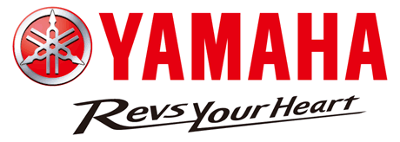
- Marketing & Social Media Specialist and Sales Associate at Yamaha Itani Lebanon (1 Year of Work) 2016 –2017
- Manage the Social Media Pages & OLX Platform
- Upload Daily Advertisements of the Products with Specs & Features
- Assist in Sales & Customer Service

- Social Media Coordinator at AUST 2015 – 2018
- Founder of the University Instagram Page
- Upload Daily Advertisements of the University’s News & Activities
- Reply to Students inquiries & Assist them

- Marketing & Advertising Supervisor of My Family Business – Chaar Buy & Sell Cars 2015 - 2019
- Use Digital Marketing Strategies
- Manage the Facebook Page & OLX Account
- Upload Advertisements of each car with specs & features

- Skills:
- Language Skills: Arabic, English, French & Spanish

- Computer Skills: HRIS, Microsoft Word, Excel, power point.

- Professional Skills: Human Resources, Recruitment, Communication, Sales, Customer Service.

- Personal KSAs:
Young, confidant, quick learner, self-motivated, Full of Hope for my future endeavors, Very Dedicated to the Company That I work for, Hard Working, continuous self-drive to successful achievements.

- Activities :
- Professional Karting Racer at Pit Stop Karting Zouk Mosbeh (Membership)
- Interest in: Travelling, Socializing & Public Relations, Sports (Especially Motorsport), Enjoy Long Walks, Cooking, Watching YouTube Videos of Motivational Speakers & CEOs Success Stories.

