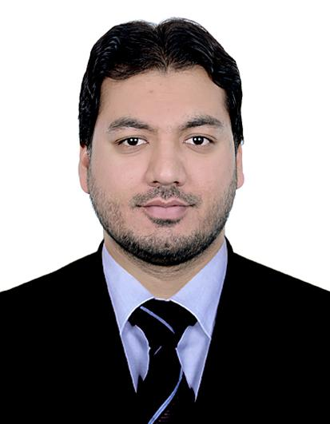  PERSONAL INFORMATION  Visa Status: Employment Visa  Nationality: Pakistan  Date Of Birth : 11 Dec1988 Marital Status: Married  PERSONAL STRENGTHS  - Innovator  - Problem Solving  - Goal Oriented  - Verbal and written communication  - Multitasking  - Team work  - Communication Skills  - Microsoft Outlook  - Microsoft Office | Curriculum Vitae  MUHAMMAD UMAIR  Abu Dhabi UAE  Contact : +(971)564600670  Email: umairfsd35@gmail.com  Objective:  Looking for important and testing position in a Vibrant testing Environment where my present capabilities and aspirations would be an advantage for the association. The employment ought to offer the open door for the self-improvement through aptitude procurement and occupation enhancement.  Technical skills and experience:  - 6 Years Dynamic Experience in the field of Banking,operation management, Accountancy, Administration,Data analyst/validation in different companies.  - ICCS (Image cheque clearance system)  - Intellect  - T24  - Peachtree  - Tally  - Quick Book  - MOS-Microsoft Office Specialist (Word, Excel, PowerPoint)  - DCAA-Diploma in Computerized applications & Accountancy  - 6 weeks internship at Askari Bank Ltd.  Integration activities & Initiatives:  - Actively Participating and perform assigned tasks in the entire integration process within agreed time frame.  - Have taken part in settled testing phases and perform UAT/UAT1/UAT2 with all scenarios assigned to us.  - Validate and performed all assigned test cases/scenarios related to our Deptt.  - System enhancement by implementing new ideas/workflows.  - Engagement in automation of inward/outward clearing.  - Perform data validation by running different phases i.e. Bronze/Silver/Gold RUN and idenfied the issues, raised on portal, forward to concern team to fix.  - Perform disaster recovery plan & SRT.  - coordinating with the vendor regarding issues faced during testing and obtain the fixes for the same.  - Involvement in performing different phases of ORT (operation readiness test) ORT1/ORT2/ORT3.  PROFESSIONAL BACKGROUND:  First Abu Dhabi Bank   Designation: Senior officer  Time Period: OCT 2014 - PRESENT  Job Responsibilities:  - Extensive knowledge of Cheque clearing and collection process.  - Maintain complete cheque Collection process from Trans guard and liaison with them.  - Maintain the MIS on daily/weekly basis.  - Reconciliation of all the inward and outward clearing cheques.  - Send the reconciliation report to the Line Manager on consistent schedule  - Scanning and uploading all the outward/PDC cheques in ICCS System  - Engage with the team to achieve SLA  - Coordinate with the branches in case of any type of discrepancy.  - Ensure to meet the Customer Satisfaction Level regarding cheque clearing queries.
Curriculum Vitae Of Muhammad Umair
- Coordinate with the branches in case of any type of discrepancy.
- Ensure to meet the Customer Satisfaction Level regarding cheque clearing queries.
- Prepare all the Returned cheques attached with each Memos and dispatch to the concern branches through internal mail on daily basis.
- Engage in clearing all Inward Cheques before Cut off time as required
- Prepare monthly statistic for management as required
- Review and recommend changes to operational procedures, forms and systems to improve efficiency, reduce cost, promote service excellence and avoid future claims as well as legal disputes.
- Followup with the branches and other banks
Dubai Timber Bldg. Mat. Tr. L.L.C. 
Designation: Accountant
Time Period: Apr 2012 – Sep 2014

Job Responsibility.

- To manage the all Accounts through an Accounting Software.
- Maintain all the accounts sheets in well-organized manner in Excel etc.
- Prepare the invoices by ensuring the LPO.
- Maintain the AR/AP Statement on monthly basis.
- Follow up regarding customer’s payments.
- Solve the customer queries on priority basis.
- Complete check and balance on all the accounts.
- Issue cheques and official receipts to the suppliers as per company policy.
- Reconcile accounts with the respective subsidiary ledgers.
- Prepare the import & Export documentation.
- Prepare the online Custom documents.
- Correspondents with the Imports.
- Maintain bank reconciliation on daily basis in an efficient manner.
- To manage Stock Inventory system.
- Maintain the daily MIS
- To make Monthly reconciliation
- Input of sales and purchases invoices, cross checking on billing.
- To prepare daily expense sheet.
- Prepare the Profit & Loss A/C.
- Assist in preparing the final accounts at the end of financial year.

EDUCATIONAL
Master of Business Administration MBA - Finance:
Riphah International University Islamabad Pakistan 2011
Bachelor of Commerce: B.COM 2009

University Of Punjab Lahore Pakistan
Intermediate of Commerce: I.COM 2007
BISE Faisalabad Pakistan
DECLARATION
I hereby certify that the above information is true and correct to the best of my knowledge and belief.

