 | NAVIA c. ghawi |  |  |  |  |  | 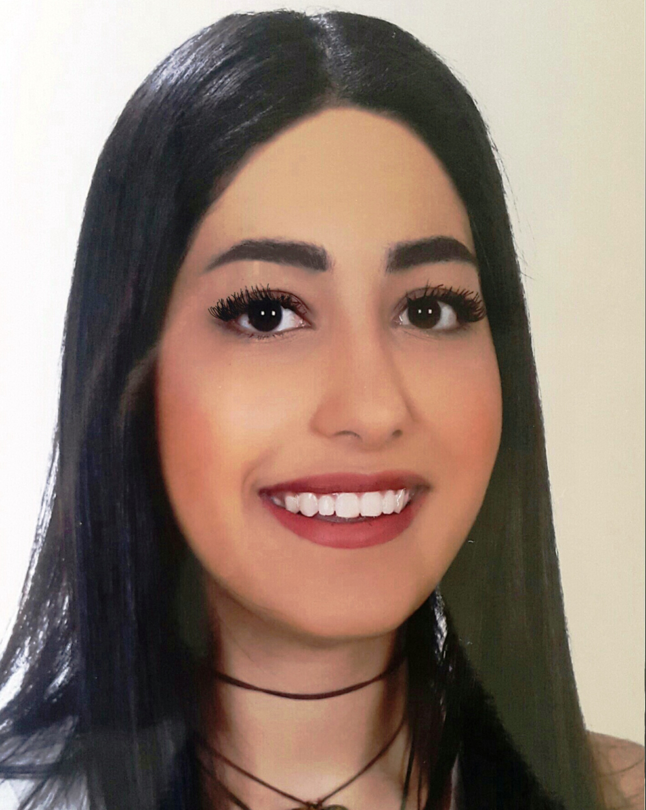
 |  | 71 19 10 18 |  | NaviaGhawi@hotmail.com |  | Beirut, Lebanon.

Academic Record

- Public Health and Development Sciences.
Balamand, Faculty of Health Sciences, Ashrafieh.
2016 – Present.

- Lebanese Official Bacc. II (Literature and Humanities)
Lycée Laure Moughaizel, Beirut, Lebanon.
2010 - 2015.

Employment History

- Qi Juices
Barista and Bar Manager
October 2015 – March 2016.

- Tailoring cocktails to clients’ needs.
- Cataloguing, inventory, and data entry.
- Monitoring working hours of baristas.

- Tandem, Lebanon.
Hostess.
March 2015 – October 2015.

- Welcoming and greeting wedding hosts.
- Managing the circulation of event attendees.

- Grand Cinemas, Lebanon.
Sales representative.
June 2014 – June 2015.

- Worked on a freelance basis to promote products and movies at the Grand Cinemas premises.
- Worked on over 10 projects, among which:
- Promoted Bank Audi visa cards.
- Launched and promoted the sales of Let’s Pop Corn.

Professional Qualifications

- Computer Skills:
- MS Office (Word, Excel, and PowerPoint)
- Internet and Social Networking

- Languages:
- Fluent in Arabic, French, English and Spanish

Achievements and Portfolio

- Certificate of contribution to the local documentary “Dear Lebanon”.
- Certificate of participation in a workshop by the NGO “Adyan” seeking to establish peace among different Lebanese sects and religions.

