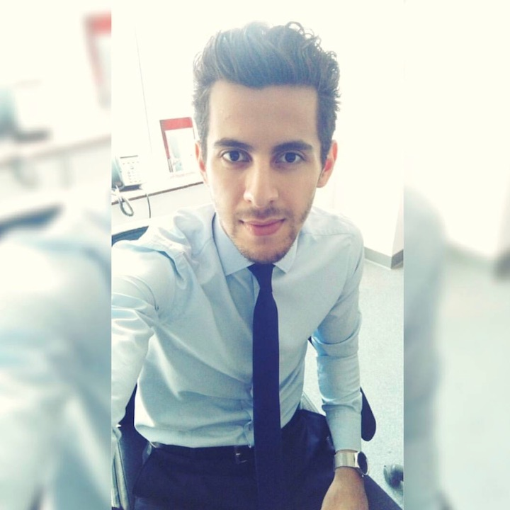
  Kuwait, Salmiya, Qatar St.
  0096551679188
  m.ghannoomm@gmail.com
  www.linkedin.com/in/MohannadGhannoum
  Nationality : Lebanese
  Martial status : Single
  Birth Date : 08/12/1995
Mohannad Ghannoum

Objective :
I have been working in the Ophthalmic field as medical representative at Medicals International Company, and I gained the following skills: direct contact with different people styles and needs, tremendous learning experience were I have learned a lot and developed many skills, high spirit of recognition, rewarding and motivation. My aim is to develop and grow in a company that exposes me to the Digital field to use & develop my skills, knowledge and experiences. I would like to grasp this opportunity and apply to work at your firm, and this is for the following reasons: gain and be exposed in a Digital Marketing field, to enrich my learning, as well as to build my professional career.

Skills
- Communication 5/5  - Ability to work under pressure 4/5  - English & Arabic language 5/5 | - Time Management 5/5  - Team Work 5/5  - Decision Making 4/5

Experience

July 2017 ( current )

Territory Manager / Medicals international
Medicals International is a leading distributor industry in Middle East in Vision care, Ophthalmology, Dental & Dermatology, with a product line of the finest companies through out the world.
I am covering Kuwait.
Duty : Maintaining great relationship with the Hospitals & Centers with Ophthalmic doctors & heads of ophthalmology, management team & staff to reveal exact needs and based on that maintain business together.
Product line : IOL’s ( HOYA ), ICL ( Staar ), Blades ( Sharpoint ), Viscoelastics ( BohusBioTech), Rings ( Intacs ), Instruments ( Rhein )
Machines : Ellex Lasers, Oertli phaco machines, Schwind for Excimer Lasers, Tomey for slit lamps & refractive examination, Optovue for OCT.
I attend operations with doctors to take the feedback once tried our consumables, quotations preparing and offers for new projects, invoicing and returns, doctors wetlabs for ICL, Stock managing at accounts, fixing machines and troubleshooting, ICL calculations, participating in conferences to present Medicals latest technologies and deliver our message and pushing the sales till we meet the targets and plans set.

Academic Background & Trainings :

Marketing bachelor degree / Beirut Arab University
Our degree is FIBAA accredited, The Foundation for International Business Administration Accreditation(FIBAA) is recognized accreditation in all German speaking countries(Germany-Switzerland-Austria)

Trainings :

- Ellex / France : Ellex Global Sales Training ( Certified )
- Oerli / Switzerland : Phaco machines ( Certified )
- Ziemer / Dubai : Galilei.
- HOYA / Dubai : IOL’s
- Optovue / France : OCT ( Certified )
- Staar / Dubai : ICL ( Certified )

Certificates :
- ICDL ( Computer office )
- Ellex Global Sales Training
- Oertli
- Optovue
- Staar
- The Fundamentals of Digital Marketing ( Google )
- Certified Digital Marketing Specialist In Social Media
( Morgan International / Digital Marketing Institute Dublin Ireland )

Achievments :

Closing a tender of $70,000 in consumables over 2 years against 5 competitors in governmental hospital.

Downloading for the first time a new technology ( Laser Machine ) in Kuwait market.

10 % Sales growth in my current department.

Closing a deal of 1 million Dollars with a key Doctor.

Hobbies & interests :

- Reading : 1 Hour Daily.
- Sports : Fitness / Soccer.

