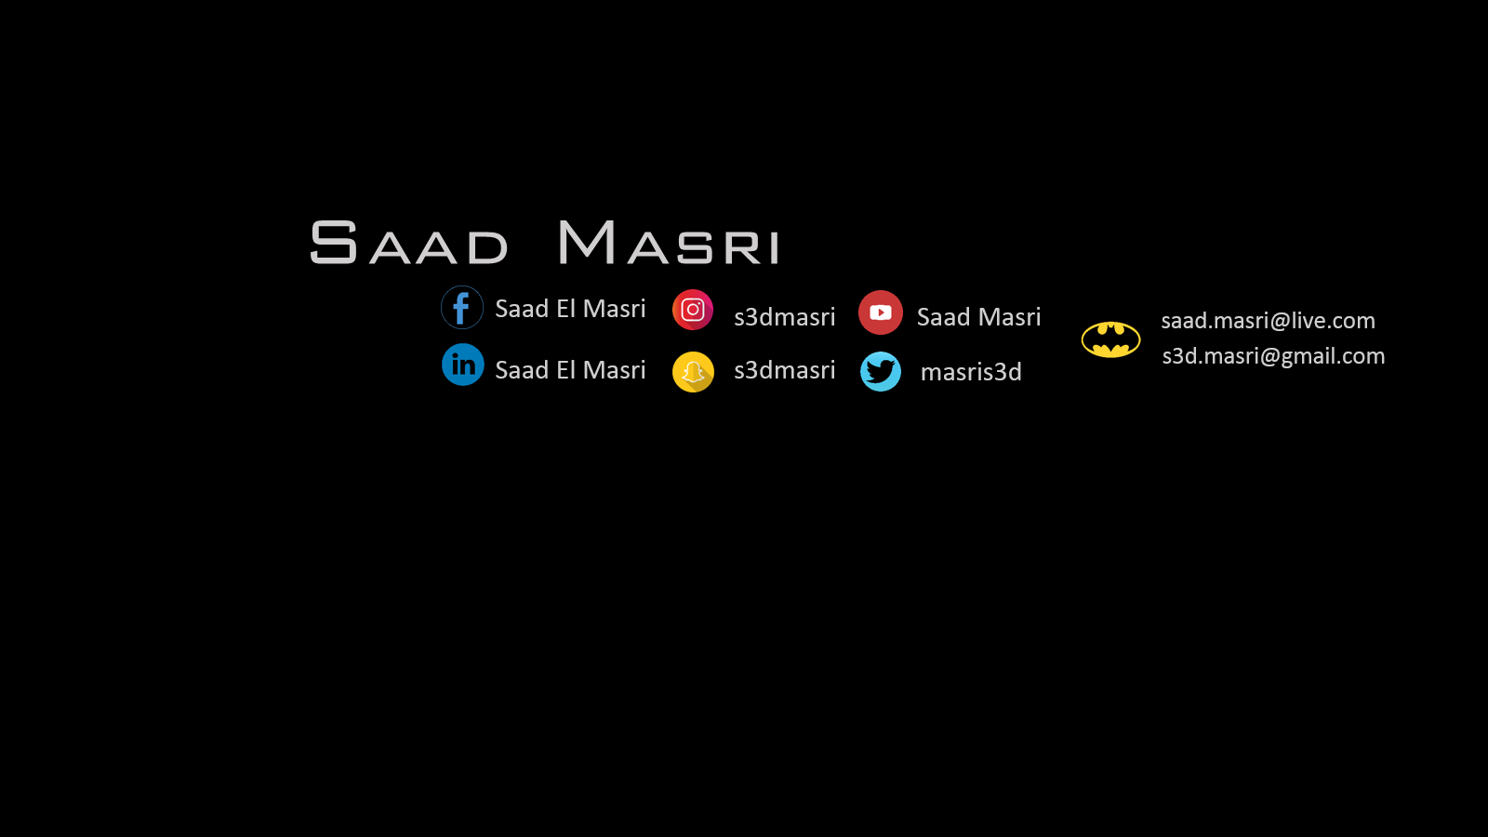
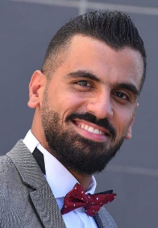

Saida, Lebanon | phone: +96170093895 | Nationality: Lebanese | Date of Birth: May 23rd, 1990

Objectives:
Seeking a full-time job at your company where my skills and knowledge can be utlized and further developed.

Education:
BA, Communication arts, Radio and TV | Lebanese International University (LIU)

Experience:
El Masri Gift shop | Manager February 2006 – November 2009
Start-up for a special gift-shop.
Special donation from the customer to under-privileged neighborhood residents

Al Asreya Library | Sales August 2010
Managing daily sales
Receiving reflection from customers.

The Crazy Phone shop | Sales June 2009 – December
Sales and technical support for customer phones.

Nour Music Pure Sound | Sound engineer’s assistant August 2009 - Present
Adjusting appropriate sound frequencies.
Installation of light and sound equipment.
Writing quotations for necessary sound and light systems in celebrations and concerts.
Organizing and preparing stage positions and required material for bands.

Freelancing:
Kaya Arzi website | Videographer and editor May 2017
Video Operator and editor
Presenting and news editor

MBC TELEVISION | FREE-LANCER December 2013
Follow light at “Bahlam Beek” TV Show with Periba Production.

ALJADEED TV | FREE-LANCER
"بعدنا مع رابعة" Sound Engineer’s assistant and band managing during the show. (2015)
“Ahla Nass” with Rabeaa Zayyat , production team. (2017)
The Ring "حرب النجوم" and "أهلية بمحلية" production team. (2017)
Dubai TV | FREE-LANCER November 2017
Sound assistant

Beirut Digital District | FREE-LANCER
Participating in two Facebook event as a sound operator
Participating in the Facebook developer’s event as a sound operator
LBCI | FREE-LANCER
Car-politics, sound engineer (lawein waslin with Dima Sadek)

Projects in KSA | FREE-LANCER
Events, production, backstage, assistant sound and light, operator.

Internship:
Future TV | editor, communication department.
TV presenting participating with Mr. Chadi Khalaf (MTV host)
TV presenting workshop at Al AMAL INSTITUTION south Lebanon, with different anchors from NBN, AL JADEED, AL MAYADEEN and BEIN SPORT.

Skills:
Soft skills:
Journalism, Research, PR, Editing, Events management, acting, performing arts, social media
Computer Skills:
Microsoft office, Adobe Illustrator, Adobe Premier, Adobe Audition, Avid Pro, Final Cut

Languages:
Arabic – English – French
Community Service:
SAIDA | LEBANON
. Volunteer with the Big Blue Association to clean the public shore and the islands of Saida.
LIU | Saida
. Photographer of many events, volunteer and a member of “Al Ghad Al Afdal club” (social
Club) and event.

References:
AVAILABLE UPON REQUEST ‘concerning some projects’

