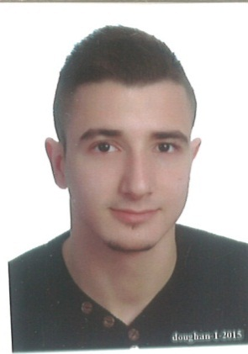
Wassim Ahmad Ramadan
Beirut – Lebanon, April 30, 1993
Tel: +961-1-788320 (home), +961-70-682824 (cell.)
Linked In: www.linkedin.com/in/wassim-ramadan-7824a3105
e-mail: wassim-ramadan@hotmail.com

SUMMARY

My aim is to associate and be part of the challenging team which strives for the better growth of the organization. I would like to gain valuable work experience, learn new skills, enhance my talent, and become a team member who excels at working towards becoming an asset to my organization.

W O R K E X P E R I E N C E

DOLSI Ice Cream & Chips Factory-Hadat Executive Accountant Dec 2016 – Present
Junior Accountant Apr 2016 –Oct 2016
Responsibilities:
- Bank Reconciliations and monitoring data entry,
- Expenses and payroll preparing,
- Handling all local and overseas Suppliers Accounts.
- Supervising daily final delivery checkup of all company sales rep. cars loading Ice and Chips.

Deloitte & Touché (“M.E”)-Beirut Financial Auditor (Internship Program) Oct 2016 – Dec 2016
Responsibilities:
- Bank Reconciliations.
- Report Checking and cross referencing.
- Money laundering Statements.
- Analyze the Sample.
- E-learning program.

Arab Finance House (AFH Islamic Bank)-Beirut Customer Service Internship Nov 2015 – Apr 2016
Responsibilities:
- KYC update for old customers.
- Follow up with customers.
- Signing FETCA, Rights and duties agreements.

Bank Audi-Head office (sales department) Internship Oct 2015 – Nov 2015
Responsibilities:
- Car/Personal loan application checking.
- Follow up with Direct Sale Force (DSF) for missing information.
- Connect with CDR and transferring the application for approval/rejection.

Kidzmondo-Beirut Waterfront Establishment Educator Dec 2014 – Oct 2015
Responsibilities:
- Teaching children’s how to play in the establishment and taking care of them.
- Employee of the month. September 2015.

E D U C A T I O N

Lebanise International Universitu, (LIU) Beirut. Mastes in Business Adminstration (MBA) Accounting (2017- Present)
Beirut Arab University Beirut, (BAU) Beirut. Bisiness Adminstration Degree: BA Banking & Finance (2011-2015)
Reneh Moauwad High School Beirut, Lebanon. Lebanese Bacc. II SE ‘Socio Economics’ - 2011

T R A I N I N G

- Training at Bank of Beirut with coordination of AMIDEAST. “Work Success Boot Camp” (Summer 2015)
- Training program at BANQUE DU LIBAN (BDL). (Summer 2014)

Certificates
- International Computer Driving License. (I.C.D.L.)

ADDITIONAL INFORMATION

-Languages: English / Arabic
-Computer Skills: Microsoft Office with excellent command of widespread packages (spreadsheets, databases and word processors)
-References available upon request.

