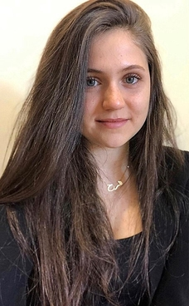
LANGUAGES
Arabic native language
English fluent
French fluent

Personal Info
Address
Saadoun square,Samra,Tripoli
Lebanon

Phone
76190800

Email
Farahfattal2@gmail.com

Date of birth
1995-04-02

Education
Lebanese University – Hadath, Master 2 in Chemistry and Biology of Bioactive Molecules
2018- present
Optimization of Caco2 cells culture in vitro cell models for permeability studies

Lebanese University – Fanar, Master 1 in Biochemistry
2017- 2018
- With appreciation: 15/20
- Deep training in Biochemistry
- Acquired a solid foundation and knowledge in this field

Beirut Arab University – Tripoli, Bachelor’s degree in Biochemistry
2013- 2017
GPA: 3.61/4

Rawdat El Fayhaa Secondary School – Tripoli, Baccalaureate "Life sciences"
2013

EXPERIENCE
Pharmacy Internship – Pharmacy Maya, Tripoli
- Practiced the basic customer service skills that are part of the pharmacist’s duties and verified prescriptions brought in by patients
- Collected payment

Training in Food testing laboratory - Quality Control Center Laboratories, Chamber of Commerce industry and agriculture, Tripoli
August 2016 - September 2016
General overview of all food laboratory testing for better understanding principles in this field

Training course in ICDL - Beirut Arab University, Tripoli
July 2014 - July 2014

Farah Fattal
Master 2 in Chemistry and Biology of Bioactive Molecules graduate
Work for a company where I can put my experience, education and skills to ultimate use.
COURSES
- Cellular and Molecular Pharmacology
- Pharmacochemistry and Medicinal Organic Synthesis
- Pharmacochemistry
- Metabolism and pharmacogenomics of xenobiotic metabolizing enzymes
- Colloidal particles and drug targeting
- Cell and gene therapy
CERTIFICATES
- CMAPS certificate from ENEPLAN projects, held in Lebanon, Fanar, at Lebanese university, 2018
- IELTS certificate, degree: B2 level, 2016
- Certificate of a training course in ICDL (International Computer Driving License), 2014
SKILLS
Laboratory skills lab experience from degree level study
Organisational skills experiments completed within the timescales given
Written communication skills report writing
Verbal communication skills discuss scientific ideas across teams
Problem-solving skills ability to find new ways of tackling a problem
Computer skills proficient with Microsoft Word, Excel, and Powerpoint.

Acquired skills and competencies necessary to use a computer and common computer applications
- Offered a wide range of modules including Computer Essentials, Word Processing and IT Security

