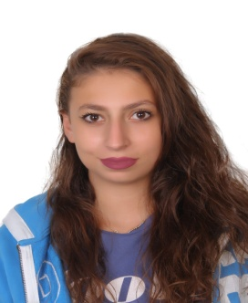
Marwa Saab
Lebanese
Born in 23/3/1999

Chemistry Graduate

- Hadath, Lebanese University
Beirut, Lebanon
- +96170804169 phone
- Email: marwasaab774@gmail.com
- Objective
- I would like to Find a place for my abilities to flourish at your successful organization.
- Education
- 2016-2019: General Chemistry at Lebanese University, Faculty of sciences 1 Rank (74/100)
- 2019: Online writing course with Udemy “the foundation of fiction(Mastery writing)”
- 2018-till now: Studying at Lebanese National Higher Conservatory of music
- spring 2018: Online Certificate “EDX tsunamies and natural disasters”
- 2011-2012: Lebanese baccalaureate (Bacc. II), Life science .Grade 15.6/20
- Professional Experiences
- Private teaching for students as an extra time job in chemistry and other subjects.
-private lessons for navy students in chemistry .
-teaching in educational centers , and work as Lecturer assistant with Dr.Maysoun Chreif about environmental concequencies on physical appearance.
- Project trainings
-Polymer project in Medical Field and its importance
-Project of “Ages of the Earth” related to Environmental chemistry course.
-Trainee at the PHD Laboratory of medicinal chemistry and natural products.
-project with Dr.Nuhad kassem about Heavy metals in atmosphere and its effect on brain cells.
-project in organic laboratory about sunscreen protections and UV light under the supervision of molecular chemistry professors .
- Languages
Arabic: Native English: Fluent French: Beginner
- Competences, Hobbies and characteristics
- Informatics: Microsoft Office, C programming.
- Traveling, sports (basket ball)
- Sociable, Intelligent, Self motivated, highly organized and hard working individual
- Social Activities
- worked as a volunteer in NGO's;- Orphan homes; -Environmental Association

References:
Dr.Nuhad Kassem : 00961 70601880
Dr.Maysoun Chreif: 00961 3432875

