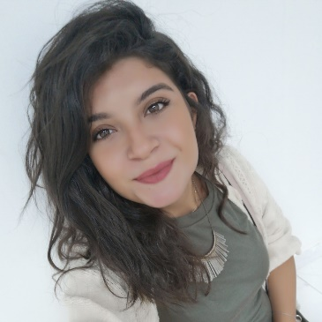  Objectives  A Highly passionate female that is looking forward to gaining a great experience in the field of Media.  languages  ARABIC: Native Language  ENGLISH: Fluent  trainings  A one-month internship at Private Magazine in Beirut. | Lebanese | Single  Experience  Media representative • Kuwait Media Center • April 21 – present  - Originating advertising ideas.  - Preparing social media strategies and campaigns.  - External meetings with the clients.  - Strategic tactics to identify the organization’s business needs.  Education  Bachelor degree in communication ARTS, JOURNALISM • 2018 • The Lebanese international university  Honor list graduate/ GPA>3  Baccalaureate/sciences • 2014 • Fajr Al-sabah private school (kuwait)  projects/ achievments  - Interviewing the TV presenter Tamam Bleik  - Certificate of Appreciation for volunteering in the huge event organizing “GENIUS MAP” in Beirut.  - Volunteering in organizing the opening of “Nothing Is missing NGO” event  - Presenter of the Communication Day in the University.  References  - Available Upon Request.
  Nour reslan
  +96566538021
  Nour—reslan@hotmail.com

Interests and Activities
- Searching and Researching.
- Reading, writing and listening to music.
- Volunteer work and social activities.

Characteristics
- Excellent Communication Skills.
- Passionate about learning new stuff.
- High Attention to Details
- Great computer skills.

Capabilities
- Excellent in Microsoft Office (Word-Excel-Power Point)

- Basic knowledge in (Adobe Premiere and Adobe Illustrator)

