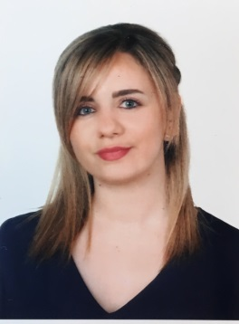 Curriculum Vitae

Address: Fanar_ Lebanon
Name: Carine
Surname: Bou Abdo
Date of birth: 6/06/1989
Contact: 03/807985
Email: bouabdocarine@gmail.com

Objective :
My aim is to succeed in a stimulating and challenging environment where I can use my skills and knowledge in the field of Communication and Public relations to achieve my goals. My experience as a former PR executive has proven to me that my profile meets the requirements for this job. With hard work, perseverance and dedication I am quite convinced that I can serve your organization and establish a successful career.

Professional experience
-Project manager/Communication & Change Management at SGBL (since May 2016)
My work is to serve as a primary interface with the clients (internal and external) and maintain an ongoing relationship in order to guarantee the project delivery. In fact, I am in charge of scheduling, planning meetings and providing follow-up on open issues until the resolution of the latter. I am also involved in the implementation of the communication plan as part of the change management process.
-PR executive and Editor at Mondanité Magazine ( June 2012-October 2015)
My job was to deal with the clients as well as the management. I was in charge of events coverage going from receiving clients to attending events, making deals, developing the network of Mondanité. Besides my PR work, I did interviews and wrote articles.
-Editor in the French newspaper AlBalad (January 2011/January 2012)
I prepared the cultural pages covering all kinds of topics (inquiries, surveys, interviews, studies…).I also worked for six months in the economic pages (Stock market, investigations, analyses, news).
-Proofreader for the French newspaper AlBalad (June/December 2010)
My job consisted on reading all the pages and correcting the mistakes as well as identifying language’s deficiencies on many levels.
-Freelance writing for the Ministry of Tourism (2009)
I was in charge of translating three booklets related to Lebanese heritage into French.
-Private tutoring since 2008
Most of my students follow secondary studies. I offer them a monitoring throughout their studies.
-Training at MTV (2009)
I translated documents from and into Arabic, English and French. I was introduced to the word of media. Throughout my internship, I discovered my potentials in this field.
-Training for 3 months at Byblos bank (2007)
I gained a large experience in terms of work in a company and precisely in the communication department. I also translated documents from and into Arabic, French and English.

Education :
Saint Joseph’s University (USJ Lebanon)
2012/2014 MA in Communication
Saint Joseph’s University (USJ Lebanon)
2010/2011 BA in Languages
Saint Joseph’s University (USJ Lebanon)
2007/2010 BA in Translation
Notre Dame de Nazareth (NDL LEBANON)
French and Lebanese Baccalaureates (2007)

Additional information
-Very fluent in French, Arabic and English
-Self-motivated with ability to work under pressure
-Multi tasked with strong organizational skills
-Certificated in Prism Methodology
-Beginner in Spanish (3 years)
-Advanced skills in Microsoft word, Excel, PowerPoint, Outlook and Internet applications, Integra, Workflow.
-Always tuned and very interested in reading.

