Youssef Antoun Semaan  Jal El Dib - Beirut  +961 70 257474  11/5/1995 | 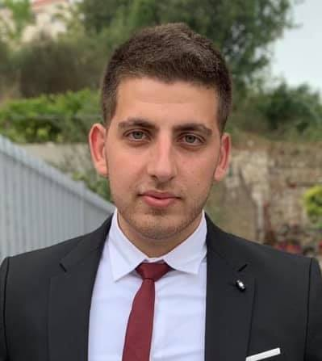

Objective: | I am a confident, goal oriented person seeking a job opportunity at your company. I am a fast learner and a team player that wants to improve his skill set.
Education: | - Antonine University ( Baabda) – Digital Marketing (Masters)  2018 - 2020  - Antonine University ( Baabda) - Marketing and Management (Bachelor)  2014 - 2018  - Antonine Sisters ( Roumieh) – SV  2009 - 2014
Certificates: | - Bank Of Beirut ( Baabda) - Hands On Banking  2016-02 - 2016-05  - Food Safety – Level 2 – Boeker  2019
Experience: | - Team Leader  GAJ contracting  2/2019-till present  - Waiter  33 herbz SAL  12/2018-2/2019  - Waiter  Ghia holding  9/2018-12/2018  - Waiter  Addmind Group  3/2018-8/2018  - Waiter  Food Trends  From 3/2016 – 3/ 2018  - Sales Associate  Aishti  From 11/2015 - 3/2016  - Sales Associate  Cortefiel  From 7/2015 – 11/2015  - Cashier  Wooden Bakery  From 6/2014 – 9/2014  - Bar back/Bartender  Juleps  From 6/2013 – 9/2013
Skills: | - Creative thinking and problem solving  - Motivation and commitment  - Teamwork  - Time management  - Recognition and respect for rules and guidelines  - Ability to listen and learn quickly  - Goal oriented approach to work  - Dedication  - Self confidence

Languages:
      - Arabic
      - English
      - French

Interests:
- Basketball
- Boxing
- Ping pong
- Socializing
- Listening to music
- Reading books

