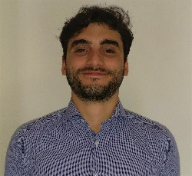  Objective  Freshly Business and Economics graduate.  Having a double citizenship while being a polyglot allows me to work in most sales ambient around the world, motivation and hard work help me adapt with any work situation I find myself in.  Skills  Languages, I speak 4 fluently:  French: C2 Italian:B2  English:C2 Arabic:C2  -Basic SQL and Python skills  -Great with Microsoft Tools  - Team work is key .  - Good in PR and public speaking.  - Extrovert with a sales driven mentality.  - Multitasking and coordination are key.  - Fast learner and always open to new ideas. | Experience  Sales • Caffitaly.Spa • 10/07/2017 - 25-01/2019  Started as a junior salesman, promoted to assistant manager overseeing sales and marketing for three stores in the Emilia Romagna Region  Real Estate consultant• 24RE • 02/10/2016 – 31/05/2017  Started off as an intern in the financing department, then moved to consulting and real estate.  Sold houses to foreigners looking to invest in Europe usually Arabs looking for real estate investment in Spain, Italy and Portugal  Education  Business and Economics •Universita di bologna  Started school in 2014 but then took a year and a half off for work, came back after that and finished, with only my thesis left to graduate in July 2019  Highschool deploma • class of 2014 • college des peres antonins  French school with an emphasis on Business and management.  Graduated with honors:17/20  Autorizzo il trattamento dei miei dati personali ai sensi del Regolamento UE n.2016/679
  ramzi Bou Rouphael
  Beirut,Lebanon 1996
  residence : Modena Via Campi 78

