Mortada Mazloum  Saydeh str.  Zalka, Mount Libanon  Libanon  Tel: +96176536932  Email: mortadamazloum95@outlook.com | Curriculum Vitae 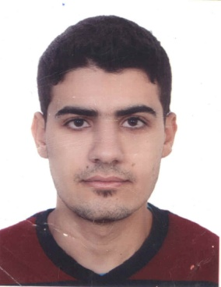
Personal Details
Mortada Mazloum
Born in 09.09.1995 in Brital, Lebanon
Single
Educational Credentials  10/2000 – 6/2007  9/2007 – 7/2013  7/2012 – 12/2013  10/2014 – 12/2014  10/2015 – 6/2016  10/2016 – recently | ENS highschool  Shahed highschool; Graduate degree: GS Baccalaureate  Taking A1, A2, B1, B1+ German courses in Geothe Institute, Beirut  Taking B2 German Course in ISZ Kassel, Germany  Studied 1st year Biomedical Engineer in LGU  Studying Computer Science at Lebanese University Fanar Campus  Will be graduating at July 2019
Qualifications  Languages  Programming Languages  Projects  Current Project | Native language : Arabic  Very good in English and German  Not bad with Spanish and French  C/C++, HTML, CSS, Java, Javascript, Assembly, Fedora, SQL, MySQL,  Prolog, Matlab, Python, C#, openGL, openCV, android, UML,  XML, XSLT, DTD, PHP, Visual Basic  Job Interview Static Website based on HTML, CSS, Javascript  Currency Exchange Stoke Desktop App based on Java  Multiuser Medical Assistant Desktop App based on Java, SQLite  Stoke Android App with local DB based on Java, XML, SQLite  Computer Store Oracle Apex App based on SQL, MySQL, Oracle Apex UI  Optical Character Recognition Desktop App based on Python and AI (Machine Learning)
Work Exprience  2012-2018 (Every summer)  10/2015-3/2016 | Worked in restaurants: CBJ, PF Changs, Meat The Fish, P’s & B’s...  Biomedical Instrumentation Internship in HNDL
Interests  Sport  Beirut, 21,6,2019 | Volleyball, Jogging, Basketball, Football, Swimming

