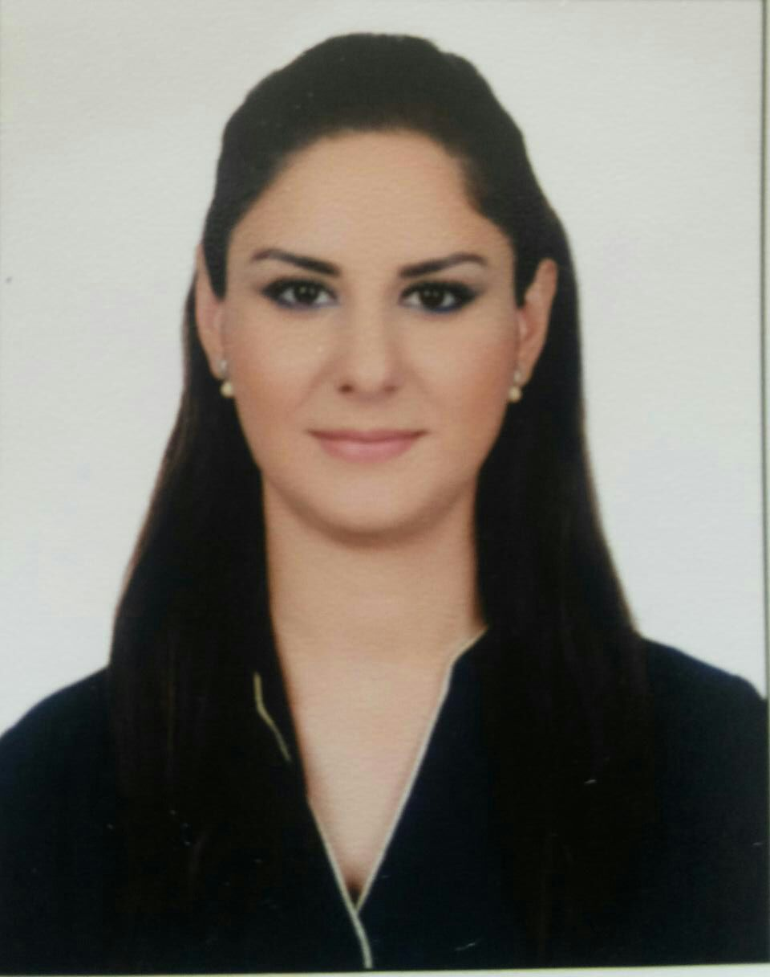
Nathalie HANNOUCHE
Address: Sin El fil, Beirut, Lebanon
Tel: +96171867287
E -mail : nathaliehannouche@gmail.com

BUSINESS ADMINISTRATION
NUTRITION AND FOOD TECHNOLOGY
Profile

Remarkably gifted and knowledgeable Food Technologist with experience in conducting experiments and analysis on products, as well as masteries in Business Administration , strategic management and marketing . Able to work on own initiative and as part of a team. First-class analytical, motivated achiever and problem-solver, capable to direct activities toward common goals and objectives.

Education

- 2012-2014
Master in Business Administration, Lebanese Canadian University and University Jean Monnet, Saint Etienne FRANCE

- 2007- 2010 :
Bachelor of Nutrition and Food Technology, AL KAFAAT University.
- 2004 – 2005 :
Senior Secondary Class, certificate in SV at the National Orthodox school-Akkar.

Work History and Professional Training

  - January 2011 to September 2014
Working at “MACCAW”, Hadath, Beyrouth
Quality control and Supervisor
- Concentration of chemical boiler
- Water analysis (tds, hardness, ph, microbiologic/total plat count and coliform)
- Reading microbiological test of juice and water
- Quality control on production line of juice (glace/tetrapack lines)and milkshake (all step from sterilization to final product )
- Management of stock and delivery order
  - December 2010 to January 2011
Working at '' keyrouz bakery ''- jisr l bacha ,
Quality control and supervisor
  - June to October 2010 :
Working at ''MAYRIG'' – Rabieh,
Quality Control and Assistante Administrative.
  - 2007 -2010:• Training in Microbiology, Parasitology, Biochemistry and Food Chemistry at the lab of AL-KAFAAT university.
• Training quality control (ISO 22000-2005,
HACCP, Hygiene ) at “Chef Ramzi SAL” Industry
Fanar.
• Training food industry (disinfection, codex alimentarus) at the same company
Computers Skills

MS word, excel, access, power point, Paint, Adobe Photoshop.

- Arabic: Mother tongue.
- French: Fluent (Speaking, Writing, Reading).
- English: Fluent (Speaking, Writing, Reading).

  - Hobbies: Gym, Aerobic, Swimming.
- Lebanese, born on the 25th of March 1987.
- References Available upon request
- Note: Holder of a Lebanese driving license.

Languages

Other

