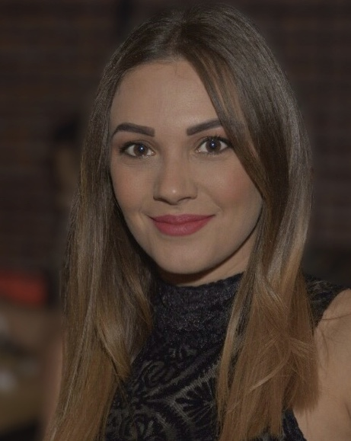
Sally GeorgesMatrak
Permanent address  Tripoli El Mina, Farah Antoun Street, North Lebanon | Contact details
Email: sally-matrak@hotmail.com
Tel : +961 3 16 54 49

I am a highly enthusiastic and results oriented professional, who enjoys being part of, as well as lead, a successful and productive team. Quick to grasp new ideas, concepts and develop innovate and create solutions to problems. Able to work well on own initiative and can demonstrate the high levels of motivation required to meet the deadlines.

Professional Experience

Jan 2019 – Mai 2019 “Marketing Department” at Sports District Complex.
- Head of the Marketing department.
- Ensuring the best online presence of our company (Managing Face book and Instagram)
- Supervised booking order and reservations.
- Develop marketing strategies to achieve the organization objectives.
- Develop branding content and coordinate new design with adobe.
- Conduct market research to identify opportunities for promotion and growth.
- Create new marketing strategies to increase the numb of customers.
- Work closely with clients to identify their needs and challenges.

Sept 2018 – Nov 2018 “Marketing & Reservation Department” at Ad Effect Advertising Agency
- Managed complex sales processes and negotiations to a successful conclusion.
- Supervised booking order and reservations
- Develop partnerships with local business to secure third party promotions
- Work closely with clients to identify their needs and challenges and provide solutions oriented campaign themes.
- Coordinated with internal business divisions, agency partners and local vendors to guarantee on time, cost-effective delivery of all marketing communications materials.
- Proofed and approved production and printing drafts of promotional materials

August 2017 – March 2018 “Public Relation” at Siba Media Production
- Ensuring the best online presence of our company (Managing Face book and Instagram)
- Developing advanced CRM skills by dealing with a wide variety of customers.
- Review essential financial documentation regarding declarations and payments (VAT, social security…) to comply with the governing financial rules and regulations of the country.
- Schedule meetings with the customers.
- Developing team work skills by working with the marketing team on marketing planning and consultancy program.

October 2016 – May 2017 “Marketing Coordinator”, at Ghandour Advertising Agency:
- Working with several companies on a wide variety of outdoor advertising like billboard, unipole, minipole, bridges etc.
- Work with client services to facilitate proposals and schedules.
- Assistthe IT and the Designer to ensure that current technologies are being implemented correctly.
- Work with both client services and client throughout the duration of a project.
- Assist in the marketing Campaign for “Properties plus Cyprus”.
- Developing a new event in Tripoli called “Spring Festival 2017”.
- Working as accountant (Data entry and invoicing, doing the Bank reconciliation, Implementing a good filing system).
Feb 2012 – May 2012 completed a 3months internship in “Customer Services” at First National Bank
- Execute Banking operations such as money transfers and checks.
- Execute Banking services such as opening an account, internal money transfer, external money transfer, debit invoices, LC, cash collateral, loan and western union transfer.
- Data entry and invoicing
- Communicate with suppliers and vendors

EDUCATION & QUALIFICATIONS

2017- Present Masters of Business Administration (MBA), Lebanese International University LIU, Lebanon.
(Economics for Managers, Corporate Finance, Strategic Management & Corporate Governance, Accounting for Managers, Managing Human Resources…)
2013- 2016 Bachelor of Advertising and Marketing, Notre Dame University NDU Barsa campus, Lebanon.
(Media plan analysis, Creativity and copy, Principles of Advertising, Studio workshop, Graphic, Media planning, Editing, Basic design, Global Marketing, Mass communication, World Cinema Survey, Principles of pub Relations, Ethics and Leadership..)

2012 Lebanese baccalaureate in Economics,Dar En Nour School, Dahr El Ein.

PERSONAL SKILLS
- Presentation and communication skills
- Written and verbal communication skills (built up through essays, presentations and coursework during my time at school/college)
- Self-motivation and ability to take the initiative
- Leadership ( able to motivate and direct others during my time at school by being delegate of the class)
- Teamwork skills ( work as a team in my internship job)
- Problem solving and flexibility
- Ability to work well under pressure
- Computer skills: adobe Photoshop, illustrator, premiere pro, after effect, Word-processing, using databases, spreadsheets, the Internet & email using Microsoft Office Pack, other soft ware’s, programs used … etc.

LANGUAGES
- English – French - Arabic (Fluent)

ACHIEVEMENT
- Social media specialist for Tasty restaurant, Professional sport players and architects.
- PR project; rehabilitate an old house and helping poor family, the project was presented on Al Ain TV, with the Star “Cyrine Abdel l Nour” (BilaHoudoud program)
- Events planning; Rally paper, Open air party, Parties and Bachelors.
- Posters and brochures for Companies, Nightclubs and High schools parties.
Seminars in social media, promote an E commerce, technical approaches in advertising via social media and internet projects

REFERENCES
- References are available upon request

