Mreijeh-Beirut-Lebanon
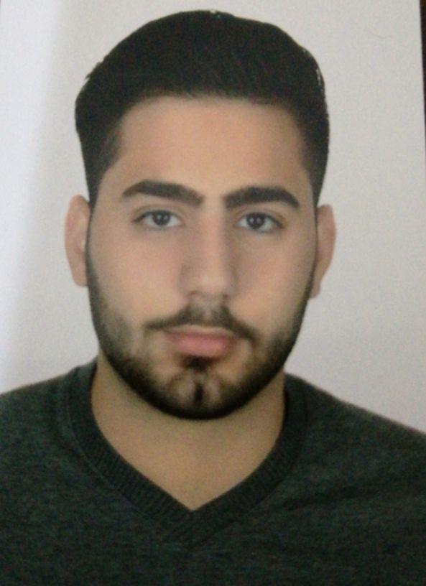
(+961) 76-044322
Email : ​ibrahim.bob.shehab99@gmail.com
Lebanese-male-single
23 years old

IBRAHIM SHEHAB​

OBJECTIVE :
​As a graduate student, i would like to peruse a job that compliments my obtained skills. I find this job opportunity very interesting considering your well reputed company and its well-known name.

EDUCATION :
- Degree in sociology and Economics (BACH2) Imam Al-Hassan school 2016
- Bachelor’s degree in marketing from the Lebanese university (year 2019-2020)

SKILLS :
Detail oriented
Very sociable and persuasive
Excellent communication skills
Excellent computer skills

Work Experience:
- Worked as sales man at shehab shoes shop (from 1-2017 till 5-2017)
- Worked as waiter and cashier at pizza hut ( from 7-2017 till 11-2017)
- Worked as a runner at iris beirut (from 2-2019 till 7-2019)
- Working as a sales representative at panda charcoal (from 8-2020)

INTERESTS:
- Keeping up with latest news in Economics, stock market and technology
- Reading books
- Football

LANGUAGES:
- Excellent english language

REFERENCES:
- Ahmad kamar al deen and mohammad sabbagh - managers in pizza hut badaro
- Mohammad shehab owner of shehab shoes- borj al barajneh
- Amin Hmedeh and Elie Deeb managers at iris-biel
- Ali khalifeh owner of panda charcoal

