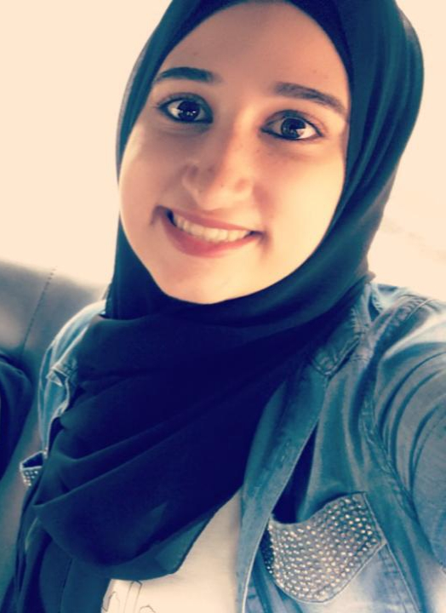 |  |  |  | sARA SABRA  To obtain an important position at work.
CONTACT INFORMATION  EMAIL  sarasabra2017@hotmail.com  ADDRESS  Beirut, Lebanon  PHONE  +961 71536723  LANGUAGES  Arabic  Excellent  French  Excellent  English  Good  SKILLS  - Listening to others when they communicate, asking questions to better understand  - Creativity  - Communication.  - Ability to Work under Pressure.  - Decision Making.  - Time Management.  - Self-motivation.  - Flexible |  |  | EDUCATION  Lebanese University  Bachelor’s degree in Management Information System (Business Computer), faculty of Economics and Business Administration.  Hadath , Beirut(First branch)  2015-2019  WORK EXPERIENCE  Telemarketing  so pure  Beirut  July/2017 – September/2017  A good communications with the clients for sale our products, and work as a team.  Private teacher  Beirut  2015  I teach my private students in the home afternoon, for be very good in math  Computer Skills  MS Office  - Word  - Excel  - Outlook  - PowerPoint  - Access  Database Management  - MySQL  - SQL  - Oracle  Web  - HTML  - CSS  - JavaScript  - WordPress  Software Skills  - Java  - PHP  - MySQL  - SQL  - C#  - JavaScript  - C++

