Howayda Bennani kkk
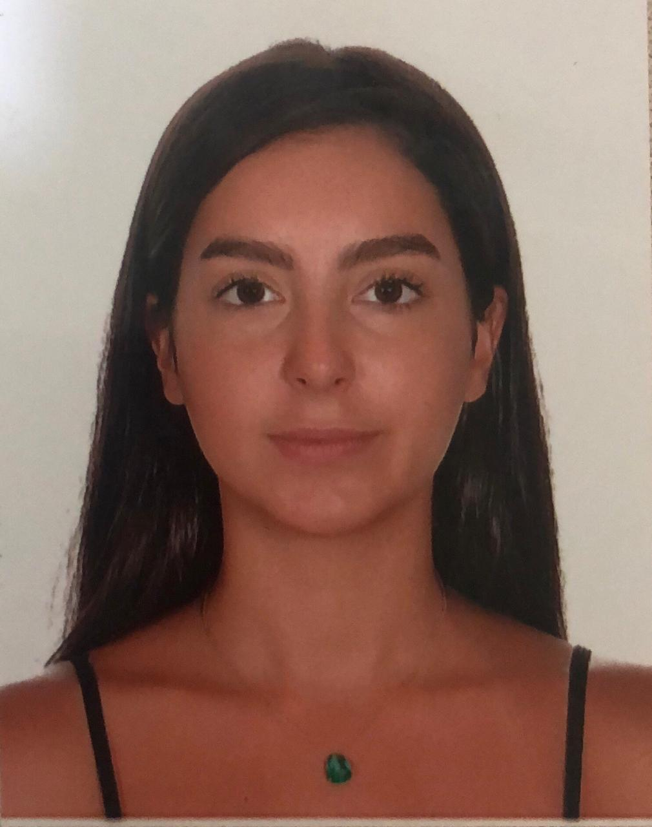
Beirut, Bechara El Khoury Street
Lebanon
Email Address: howaydab@outlook.com
Mobile Phone Number: +96171237543

Personal Information

Birth Date: | 19 / 06 / 1993
Gender: | Female
Nationality:  Place of birth : | Lebanese  Lebanon , Beirut
Visa Status: | Citizen
Marital Status: | Single

Objective
A skilled candidate; looking for a challenging role where my skills, knowledge, on-job-trainings and related learning experiences can be enhanced and utilized effectively

Education
2011 - 2015: Bachelor in Mass Communication – Beirut Arab University
2010 – 2011: Baccalaureate “Economics” – Saint Severius College

Career Background
June 2017 – June 2019: Flight Attendant – Middle East Airlines
Main Tasks:
- Security & Safety Checks
- Escorting clients to allocated seats and aiding in changes & upgrading requests
- Food & Beverage Service
- Attending to clients’ special requests and calls

January 2016 – May 2017: Sales Representative – “Bennani Cars” showroom (family Business)
Main Tasks:
- Aiding in selling process (client inquiry – vehicle presentations – price negotiations – sealing deals)
- Maintaining stock inventory
- Issuing Monthly Sales sheet
- Following up on vehicles purchase orders and receiving dates

Training Experience

- On the job training for position attained
- SEP training (Safety & Emergency procedures) – MEA
- CRM – MEA
- First Aid Training – MEA
- Security Training (Hijacking & bombs) – MEA

Personal Achievements, Certifications & Skills
- Participant in AIM festival – Arab Innovation Media – Dar El Opera , Egypt
- LCDL “International Computer Driving License” – BAU
- Excellent Communication Skills
- Strong Interpersonal Skills

Languages
Language | Skill Level
English | Intermediate
French | Beginner
Arabic | Native Language

References:
Mrs. Iman Sakakiny: Head of Cabin Crew Training: +961 03815865
Mrs. Amal Nahhas : Senior Cabin Crew & Quality Controller : +961 70927707

