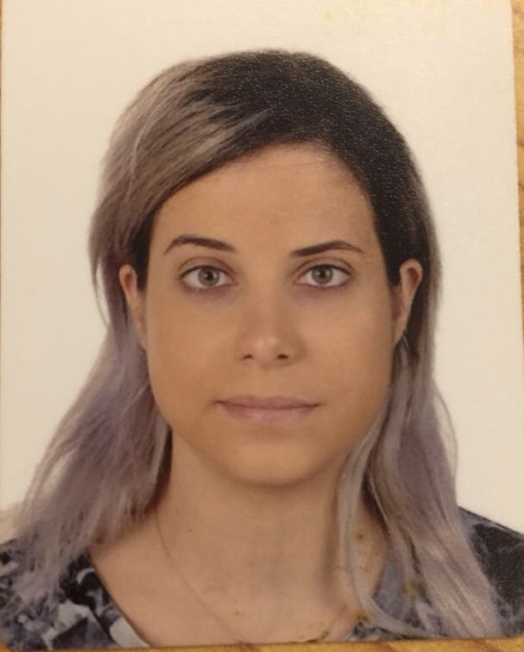
Objective

I am an ambitious person with a rather responsible character. With my shy experience in the professional field, I am eager to begin in an entry level position where I can utilize my organizational skills, my time management knowledge and of course my academic background. This being said, I aim to pursue a career in a reputable enterprise that will expose me to various challenges, which will come to enhance my personal and professional talents; helping me grow and thus giving me the opportunity to grow the business.

Experience

Main Operator at Nestle “works for products in Lebanon” , Dbayeh | Covering full timer main operator annual days off Till Present
Responsible of managing the Calls, Organizing meeting schedules, making sure all external envelopes are sent to the internal responsible person with full confidentiality.

Main Operator at Donation Blood(NGO), Dekwene | October 2017 until February 2018
Responsible of managing the calls, taking requests from the people who wants blood and working on providing their needed requests.

Sales Assistant at Mal Mia Shop, Fanar  Seeking customer needs & going extra mile with customer service. | June 2016-September 2016(summer job)
Technomenia S.A.R.L  IT distributor / Dekweneh, near freeway  Director: Joseph Haddad | July 2015- May 2016
Education

Graduated in Political Science
Sagesse University of Lebanon – Academic years 2012-2018

Law major
Sagesse University of Lebanon – Academic years 2012-2015

Terminal- L.H
Antonines Sisters School- Academic year 2012

Key Competencies

- Solving problems
- Able to work under pressure
- Customer satisfaction
- Dynamic, flexible, well organized, disciplined
- Proven experience to work in team
Computer Literacy
Microsoft word, excel & PowerPoint.

Languages

Arabic- Mother Language, French-fluent& English-fluent.

Hobbies and activities

Member at “Chabibeh Sporting Club” as a Basketball player for a third division female team.
Member at “Sagesse University Club” as a Basketball player for female team.
Playing KickBoxing From One year till Present.
Playing Piano.

References
All references are available upon request.
Tina El Helou.

