Elisar Sabra  Bachelor in Business Administration | I was born in Bordeaux (France) on 8/11/1998 and I currently  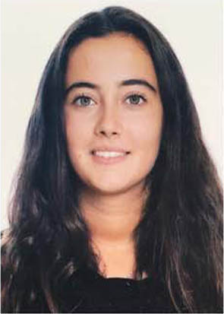  live in Beirut, Lebanon. I am a holder of dual Lebanese and  French citizenship.  +961 71300514  elisarsabra@hotmail.fr
ㅡ  Objective | I am an independent, self –motivated and sociable person, seeking a future challenging position in your progressive organization that will utilize my skills and abilities.
ㅡ  Experience | Alfa Telecom (Lebanon) - May 2014  Alfa is a leading mobile network operator in Lebanon. This internship allowed me to gain knowledge about the industry namely the mobile communication system, network distribution and customer service.  Chamber of Commerce, Industry and Agriculture of Beirut and Mount Lebanon – 1 July till 31 August 2017  The Chamber is the largest and most influential business institution in Lebanon. Within its Center for Economic Research, I participated to the preparation of macro- economic reports, bilateral trade reports and I assisted in elaborating micro-economic reports and feasibility studies related to MSMEs.  Banque du Liban- Foreign Affairs Department - 15 May till 15 June 2019  FAD is mainly involved in the preparation of studies on the relationship of the Banque du Liban with domestic and foreign institutions. It prepares reports, studies and researches and gives opinion on files presented by internal and external units. My internship allowed me to acquire practical knowledge about BDL and FAD, where I was in charge of the preparation of informational pamphlets and contributed to an internal research paper.  Institute for Finance and Governance – 16 June till 19 July 2019  IFG provides expertise and solutions for the banking sector within the MENA region and advocates for corporate governance in the private sector. During my internship, I learned about the importance of good governance, its principles and effects on Lebanese companies and I was in charge of the preparation of a brochure about IFG.
ㅡ  Education | American University of Beirut – AUB (Lebanon) / Bachelor in Business Administration (Graduated in May 2019)  Concentrating in Finance. Key courses: Financial Markets & Institutions, Investment Management, Valuation Methods, Commercial Bank Management and Risk Management.  University of California Los Angeles – UCLA (USA) / Summer Exchange Program - June till August 2018  Within my BA cursus at AUB, I took 2 humanity courses at UCLA during this 6 weeks Summer Exchange program.  Grand Lycée Franco- Libanais de Beyrouth (Lebanon) / French Baccalaureate in Sciences (emphasis Mathematics)- August 2001 till May 2016  I Graduated with Honors (Mention “Assez-bien”) with an emphasis in math.  Communication: excellent written and verbal skills in English, French and Arabic.  Computer: proficiency in Microsoft Office and MAC.  Volunteering: AUB Outdoors’ construction team, Student Mentor in Action Against Hunger.  Interests: Swimming, Reading, Traveling.  ㅡ  Skills

