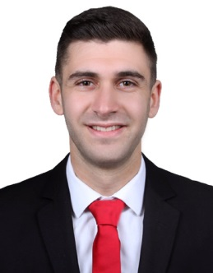
Hussein Mohamad Mohsen
hsen.mohsen@hotmail.com
(+961)70 871 496

Address: Souk Al Ghareb, Mount Lebanon
Date of Birth: November 1995 (23 years)

OBJECTIVE
Obtain a challenging position, mainly in the accounting department or as a sales associate. Additionally, applying creative problem solving and fine management skills with a growing company to achieve optimum utilization of its resources and maximum profits.

EDUCATION
Dec. 2018 Aie Serve Certificate
The Club Initiation and Management Training

Oct.2015- Sept.2018 Arts, Science and Technology University in Lebanon, Beirut
Bachelor’s Degree in business administration: Accounting

March 2017 Mira Training Center, Hamra Street, Beirut-Lebanon
Web Design Developer (HTML5, CSS3 and Social Media)

Sept. 2013- May 2015 Maroun Aboud Secondary School, Mount-Lebanon
Baccalaureate II: Sociology and Economics

Work EXPERIENCE
Nov.2018- Present Part Time job at Al-Riyade Club
Position Held: Basketball Coach
June 2018- Aug. 2018 Hassan Manufacturing and Trading Company Bchamoun
Position Held: Accounting Department-Trainee
Dec. 2017- May 2018 Styx Gaming and network lounge
  - It’s in Agency
Position Held: Indoor sales
- Customer Service
- Provide them with the full information regarding the products/services and promotions.

June 2017- Sept.2017 Bay-Rock Restaurant, Mont Lebanon-Lebanon
Position Held: Cashier

Dec, 2014- Nov.2016 Dar Al-Jadeed, Beirut
Position Held: Sales and Accounting at Book Fairs

SKILLS
Personal Skills: Leadership, Communication, Team-Building, Public Speaking, working under pressure, Motivating others.

Job-related skills: Data entry, Time management, Customer Service, Financial Statement Analysis, Auditing and Social media.

Languages: Arabic (Native)
English: read, written, and fluently spoken
French: Basic Knowledge

Computer Skills: Microsoft Office, Social Media, and Familiar with many other softwares.

ACCOMPLISHMENTS
Senior Project: Opening a new car rental company

Extra Courses: Tax Corporate, Applied Tax, CCS-HTML, Microsoft Office, Equal Software,

Volunteering: Red Cross (Aley)
• Attended emergency training sessions and currently participating in emergency missions.
• Supported in logistics fundraising events and blood donation.

REFERENCES
Available upon request

