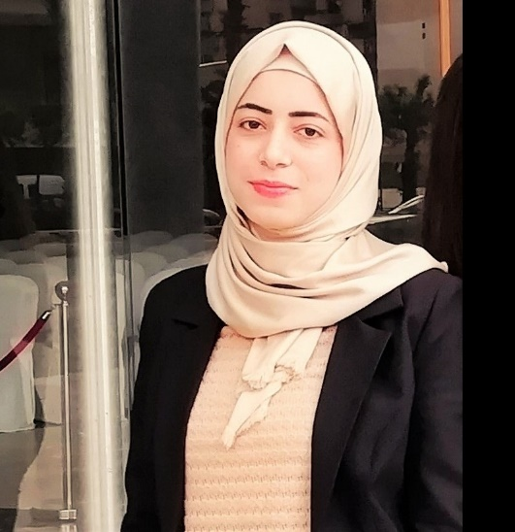
Soumaya Mamoun Wali

Address: Dam & Farez, Tripoli, Lebanon
Marital Status: Single
Nationality: Syrian
Telephone: +961 70 307 115
E-mail: soumayawali484@gmail.com

Objective
Looking for more opportunities that serve to me experiences to improve my academic skills and to upgrade my capabilities. Trying to be more practical and focusing on being leader and unique in the field of Business Management by exploiting any opportunity that will develop the leadership, mental, and communication skills. In addition to my tendency to have a good experience at this company.

Education
2017- present Beirut Arab University
Tripoli, Lebanon
Undergraduate Business Management.
GPA 3.94 /4 (Ranking: Fourth)

2017 Al Iman Islamic Schools
Tripoli, Lebanon
Lebanese Baccalaureate (Sociology & Economics)
(20th on North Lebanon (15/20))

Workshops and Competitions

2019 Beirut Arab University
Tripoli, Lebanon
- Google skills & Digital Marketing workshop

2019 Beirut Arab University
Tripoli, Lebanon
- Social Entrepreneurship workshop by Al Mashghal & Beyond.
- Social Entrepreneurship Competition.

2018 Beirut Arab University
Tripoli, Lebanon
- Competition in Data Collection & Communication with Businesses by AL Mashghal.

2018 Beirut Arab University
Tripoli, Lebanon
- Competition in Data Collection & Communication with Businesses by AL Mashghal.

2018 Lebanese Association for Scientific Research
Tripoli, Lebanon
- Entrepreneurship workshop & competition.

Projects: Marketing project (Documentary about Beirut Arab University)

Skills:
- Computer Skills: IC3 Certificate
- Teamwork: I have successfully undertaken various team projects within
both academic & non-academic environments.
- Willingness to learn: keen to develop my understanding & acquire
new skills through internships, employment, and volunteering & tendency to learn new things to affect the lives of other people.
- Language Skills: Excellent in translation (English – Arabic), excellent in writing.

Languages: English (Good), Arabic (Mother tongue), familiar with French.
English: Cambridge CLMS Certificate-B1 Level.

Interests: Sport (Basketball), writing, music, drawing.

