Farah Fathallah
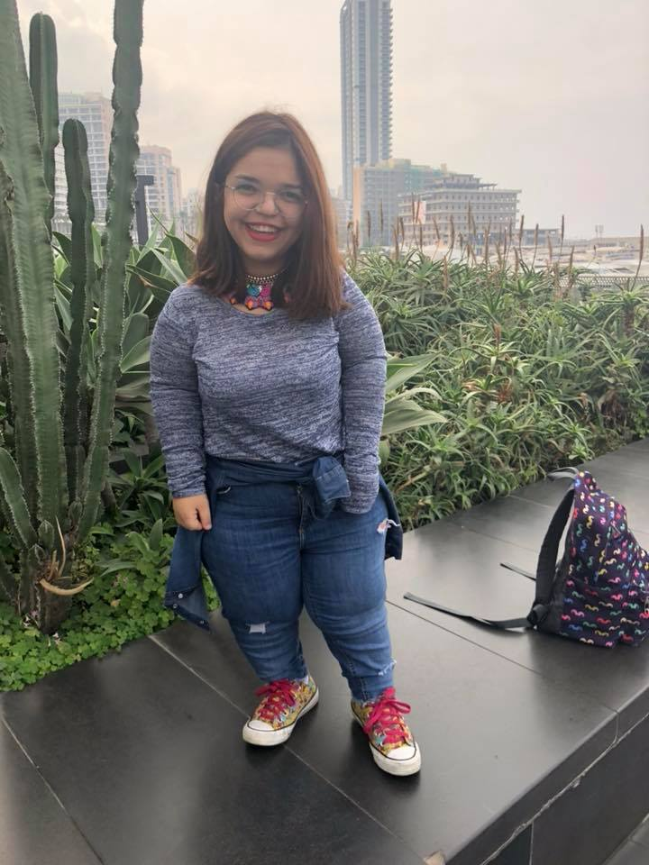
Beirut, Lebanon
71-766646 • farah.fathallah99@Gmail.com

Personal Statement

A highly motivated and hardworking individual, who is majoring in Computer Science (Credits Taken: 92/127). Seeking an internship in this industry to build upon a keen scientific interest and start a career as a developer. Mechanically minded, with a methodical approach to working and an eagerness to learn and develop personal skills. Eventual career goal is to become a fully-qualified and experienced developer.

Key Skills

- Advanced problem solving and numeracy skills
- Accomplished communication skills, both written and verbal, developed through numerous essays and presentations given during my time at college
- Ability to take the initiative and work well under pressure, ensuring strict deadlines are met, as successfully demonstrated during work experience placement project
- Flexibility, whilst maintaining enthusiasm and commitment to each project
- Proficiency in all areas of Microsoft Office, including Access, Excel, Word and PowerPoint

Education

Haigazian University
B.S. in Computer Science
Since 2017 (Present)
Have a high knowledge in:
- Website Development and Design (HTML, CSS, JavaScript and PHP).
- Database Systems (SQL, Access)
- Mobile Application Development (Android Studio)
- Software Engineering *Fall 2019*

European Lebanese School
Baccalaureate in Life Science
Graduated in 2017

Work Experience

Private Teacher in Sciences and English Language

Mentor in a Summer Camp (unpaid work experience)
Location: Super Student House – Dawhat Aramoun Near Moukahal Mosque
(Summer 2017)
- Dealing with a group of kids between 8-14 years taking full responsibility.
- Tutoring them and helping them finish their summer homework.
- Organizing educational and entertaining events for them.

Member in the Orientation Team in University (unpaid work experience)
(Present)
- Dealing with a group of school graduate students and informing them about the university life.
- Being their guide for one full day and being ready for all their questions.

