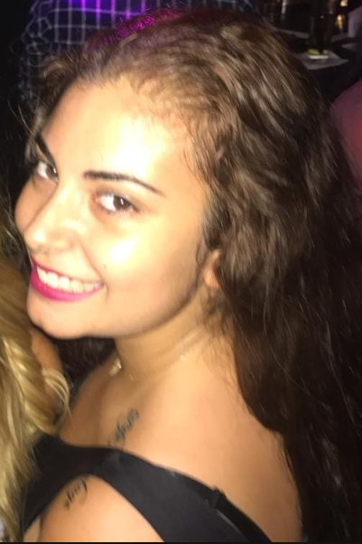 |  |  | Experience  2014  Sales Internship  SAKR Stationery- Hadath  Wholesale and retail of school supplies  Responsibilities :  1-Sales of products  2-Billing  3-Quality Control / Check if the products are damaged  4- Customer orientation according to the demand for products  2016  Marketing Internship  VERTICAL Media agency/ M&C Saatchi MENA: Quantum Tower, Charles Malek Avenue St Nicolas, Achrafieh  Responsibilities:   - Event planning  - Media planning  - Work brands on social media: Digital Marketing  - Buy advertising spaces from a multimedia advertising network  - Work the presence of competitors on different advertising medias  Education  2013    Sagesse College - section St Jean- Brasilia Baabda  BAC 2: Sciences de la vie SV Lebanese Baccalaureate II in Life sciences studies  2017  Bachelor in Marketing and Advertising  2019  Masters in Marketing of Services in collaboration with IAE Tours / France (Double Diploma: French / Lebanese)  Activities  Acoustic and classical guitar  Drawing - projects in design  Gym – ping pong – squash - hiking – swimming  Water sports - parasailing  Tourism  Accomplishments  Winner of the science competition, conducted by the nutritionists of the USJ 2013  Volunteering  Volunteering course  Volunteer with DSC (Donner Sans Compter) Blood drive 2016 in a project for this course  Computer skills  SPSS: Statistical Package for the Social Sciences (database software for market research) – Photoshop – Flash (Multimedia software) – Xplan (Monitoring company’s radio presence) - Statex de Ipsos (Monitoring company’s presence on the rest of advertising medias)

Michèle

CHEBLI 31/08/1995
 | Phone:  05/ 463494 - 05/ 464676 - 70/ 936650
 | Email:  michele_chebli@hotmail.com  michele.chebli@net.usj.edu.lb
 | Portfolio:    Michele Chebli
 | Address  Chebli bldg.  Debbas Street  Hadath-Beirut-Lebanon
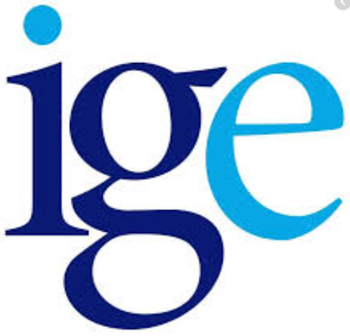   |  |  | Experience  2014  Sales Internship  SAKR Stationery- Hadath  Wholesale and retail of school supplies  Responsibilities :  1-Sales of products  2-Billing  3-Quality Control / Check if the products are damaged  4- Customer orientation according to the demand for products  2016  Marketing Internship  VERTICAL Media agency/ M&C Saatchi MENA: Quantum Tower, Charles Malek Avenue St Nicolas, Achrafieh  Responsibilities:  - Event planning  - Media planning  - Work brands on social media: Digital Marketing  - Buy advertising spaces from a multimedia advertising network  - Work the presence of competitors on different advertising medias  Education  2013  Sagesse College - section St Jean- Brasilia Baabda  BAC 2: Sciences de la vie SV Lebanese Baccalaureate II in Life sciences studies  2017  Bachelor in Marketing and Advertising  2019  Masters in Marketing of Services in collaboration with IAE Tours / France (Double Diploma: French / Lebanese)  Activities  Use this section to highlight your relevant passions, activities, and how you like to give back. It’s good to include Leadership and volunteer experiences here. Or show off important extras like publications, certifications, languages and more.

Written and spoken languages

Business English
Certificate form Saint Louis University,
Missouri, USA


