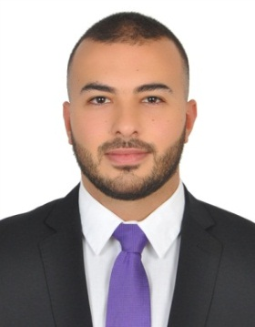
Khalid Kreidyeh

Mobile: +961-71-449981
Email: khalidkreidyeh@gmail.com
Address: Beirut, Lebanon
Nationality: Lebanese
Date of Birth: 27/April/1994

Work Objective

To have the opportunity to work for a quality organization, with long term career potential for advancement.

Work Experience

Internship - Accounting
Technical Glass & Aluminium Co. L.L.C. – Dubai, UAE (May 2016 – June 2016)

- Assist with month-end financial reports
- Post journal entries
- Help with accounts receivable, payable and bank statement reconciliation
- Manage the monthly tracking of physical inventory
- Support the payment processing team
- Data entry

Administration Department
Fransabank SAL (January 2017 – January 2018)

- Execute all tasks assigned by the Head of Payables.
- Handle accounting entries of transactions.(Expenses)
- Handle correspondences with branches and departments.
- Prepare monthly reports for accounts.

Education

Masters of Business Administration
Lebanese International University - Lebanon

Bachelor Business Administration - Accounting
2016 / University of Dubai - UAE

High School Diploma
2012 / Dubai International School - UAE

Skills

Operating System, Software, Tools & Applications
● Microsoft Dynamics GP
  - Microsoft Office (Excel, Outlook, Word, PowerPoint)

Language
  - Arabic - Mother Tongue
  - English

