CURRICULUM VITAE

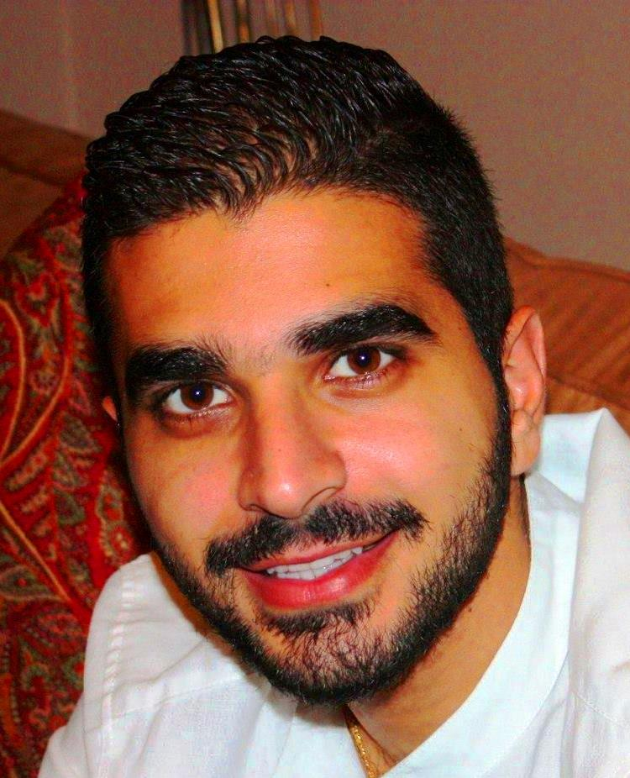

Name: Romanos Achkar

Mobile: +97156 – 7390809
Date of Birth: 01-Aug-1989
Marital Status: Single
Nationality: Lebanese
Address: Mirdif, Dubai, UAE
Email Address: romanos.ashkar@gmail.com
Availability: One month notice

Objective: To join a reputable organization where I can contribute with my knowledge and experience. I am willing to give all what I have gained from experience throughout the years through education and through my exposure to the world of media.

Education:

Name of the Institute | Name of the Degree
Balamand University - Koura | Bachelors in Mass and Media Communications.
American College of Dubai | Computer Science courses
Al Mawakeb School - Dubai | High School Degree

Work Experience:

Orient lines – Dubai
Assistant
(January 2006 – May 2006)

- Files and documents organization
- Clearing pending procedures in the accounts section

Yellow Core Production and Management
Internship
(May 2011 - October 2011)

- Job role: Assistant Producer
- Assisted in producing a famous Lebanese singer Joe Ashkar’s music video: Sayerlo; where I have also played as a model in the music video

Adam Films
Freelancer
(March 2012 - August 2012)

- Freelancer “Location Manager” in Adam Films.
My projects included commercials for:
1- Zakat
2- 2013 Audi A1
3- Sheikh Hamdan – UAE Traditions and Cultures Ad

Decision Maker TV
Content Creator / Controller
(August 2012 - December 2012)

- Working in DMTV – Decision Makers TV as a Content Creator/ Controller and doing censorship from movies and clips and creating promos.
Location: Dubai Media City

Training at MBC Group TV
Editing & Editorial Department
(13 January 2013 – 17 June 2013)

- Digitally cutting the files to determine the sequence of the film and determining what is usable.
- Overseeing the quality and progress of audio and vision engineering and editing.
- Consulting with the director, producer and/or client throughout the post-production process.
- Selecting the most effective shot of a scene in terms of drama, story relevance or continuity.
- Suggesting or selecting background music.
- Re-producing new versions of movies, talk-shows, reality shows, cartoon productions...etc, according to Airing policy in the UAE in general, & the internal agreed policy.

In association with MBC: Platinum Records – Artist Management
(13 January 2013 – 17 June 2013)
- Dealing with the outside world's demands and ensuring that an entertainer's finances are handled well, with an eye toward developing their long-term career and image.

Emirates Airlines – dnata
Customer Service Agent
(03 September 2013 – 03 August 2018)

- Check-in agent: working on shift basis at the check-in counters for various airlines such as Fly Dubai, Air India express, Kish Air, and many more
- Boarding gate agent: board the passengers to their respective flights
- Document check staff: I am responsible of passports and visa validity. Deportee handling; to prevent having a deportee that the airline pay fines.

Emirates Airlines – dnata
Travel Consultant
(03 August 2018 – 04 October 2018)

- Assisting customers interested in taking vacations, business trips or any type of visits to a different destination.
- Assessing our clients' needs, budgets, likes and dislikes to make appropriate recommendations.

Baroudi Events
Events and Marketing Manager
(10 November 2015 – Present)

- Developing a pricing strategy that maximizes profits and market share but considers customer satisfaction.
- Organizing company conferences, trade shows, and major events like weddings and all kind of parties.
- Development, production and delivery of projects from proposal right up to delivery.
- Managing supplier relationships.
- Providing leadership, motivation, direction and support to the team.
- Going to the site inspections and project managing events.
- Responsible on the budget from start to finish.

Meydan Group
Media Relations Assistant
(10 October 2019 – 30 May 2019)

- Media Server – Update content
- Accreditation – Sports Systems and Security Systems
- Updating DWC and DWCC Media Guide
- Redoing All Mailing Lists
- Updating all content on EEC, DEC and DRC Websites
- Uploading to YouTube, plus all social media accounts tour
- Mailing Lists – Create a Master List
- Newzpoint – Go through processes

Achievements:

Music Competition
20 March 2014 – 13 April 2014

I participated in a music competition on the radio 99.0 Al Arabia FM and won the competition and this win, lead me to the huge music competition program called “Arab Idol” season 3.

Fanta – Video Gaming
March 15, 2015

I took a one minute and thirty seconds video about Fanta and video games. I was the camera man, the producer, and the director of that video which was published on Fanta Facebook page.

Part time jobs

- March 13 – March 15, 2008: Working with the Dubai World Trade Center in conducting market surveys in the Dubai International Boat Show.

- April 14 – April 17, 2008: Working with Stat Ipsos Company in conducting telephone surveys.
- May 1 – May 10, 2008: Working with Stat Ipsos Company in conducting market surveys in Virgin Megastore – Deira City Center.

- May and June 2014: Extra stand promotions (Mall of the Emirates, Deira City Centre and Mirdif City Centre)

Awards received:

- Certificate of Competence in Dangerous Goods for passenger handling 21-October-2013 (Emirates – dnata)
- 2 Outstanding Athlete Awards in Basketball in High School
- Best Captain for the Varsity Team and Soccer player for the season 2011 – 2012 (University of Balamand)

Skills:

- Well versed with MS Office (Word, Excel, and PowerPoint), windows movie maker and Computer Hardware
- Final Cut Pro
- Excellent Customer Service
- Initiative and ability to achieve
- Effective Communication Skills
- Sing and play oriental keyboard

Languages:

Arabic – native English – fluent French - very good

