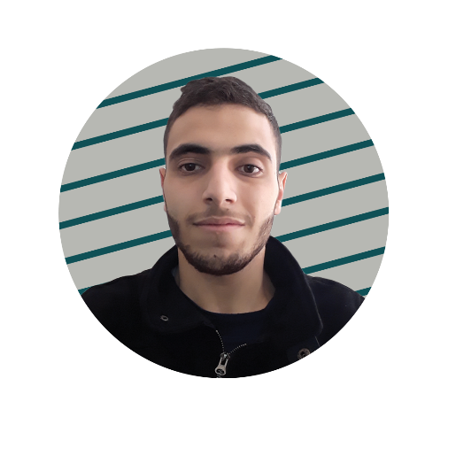 |  | Ayman Ghaddaf  Digital Journalist
profile  Digital media student with 3 years of experience specializing in photography, Video production and Editing in my university. I can also create different types of designs including graphic designing posts. My greatest strength is Creating and Video editing, also I’m good at Time Management, which enables me to get all the content ready in good and structural time.  Phone Number  81628839  Address:  Hadi Nassrallah Street- Ahla AAlam Café- Salam Building- First Floor  Email:  aymanban9@gmail.com  aymangha12@hotmail.com  most social media platform used  Facebook  Instagram |  | Education  [Official Degree in Hospitality, Ali Al Akbar Institute]  From 2013 - till 2015  Learned about hospitality management and managing hotels  Learned the basics of cooking and creating fresh food  Learned how to run a healthy restaurant  [BA Degree in Digital Media]  From Spring 2015 – till Fall 2020  Learned the basics of Journalistic Graphic Designing  Learned Digital Media Production & Journalistic Writing  Learned Digital Media Strategies & Web Designing  Work Experience  [Karaz Restaurant] [Bartender/Waiter]  As a Bartender at the Karaz Restaurant I used to work nonstop serving juices and drinks to the customers, I always kept my work tidy and clean and I’m always dedicated and passionate to my work.  [Annahar Newspaper] [An Intern]  I worked under the Annahar Newspaper Site Manager Diana Skaini as an Intern, I worked in translating some article that is given by my trainer from Arabic to English because of my English language is slightly better than my Arabic’s and little by little the process is kept on progressing.  Skills  Photography  Videography  Digital Media Production Editor  Journalistic Graphic Design  Digital Media Design  Journalistic Writing  English / Arabic

