Abdullah
Homsi
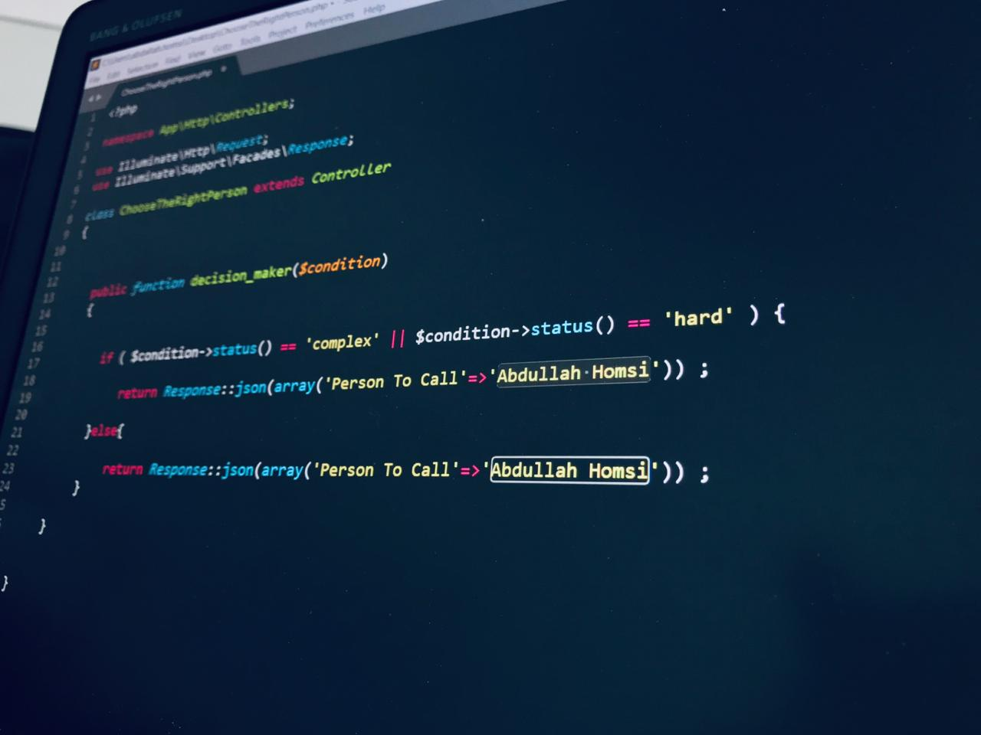 |  |  |  |  |  | Abdullah  Homsi

Experience
2016.08.15 – Current time
Full Stack Developer • Royal Financial Trading
2016.05.01 – 2016.08.15
Software Developer • Vilo.ai
2015–2016
Web Developer • Cedars Contractors
2012–2015
Math/Physics Tutor • Private Tutor, Al-Masar school, Genius Student Center

Education
Lebanese International University, Beirut
- Masters in CCE [2016-2018]

Lebanese International University, Beirut
- Bachelor of Science in CCE [2012-2015]

Areas of Expertise
- Developing secured web portals.
- Developing responsive websites with custom CMS
- Developing Custom APIs (web to hardware communication, web to web communication, web to mobile communication).
- Integrating Payment Gateways (Chine Union Pay, Neteller, Skrill, PayPal…)
- Business Analysis Reporting.
- Web security assessment.

Technical Skills
- Languages: C++, Java, Python, PHP, JavaScript, AJAX, Json, XML, HTML5 & CSS3, jQuery, AngularJS, Typescript, Bash Scripts, PL/SQL
- Frameworks:
- Backend: Laravel, CodeIgniter, Spring, ASP.Net MVC.
- Frontend: AngularJS, ReactJS, Bootstrap.
- Databases: MySQL and SQL Server
- Web services soap and rest secured API connections using encryption/decryption and Hashing Algorithms
- Web Server administration (WHM and cPanel): installing SSL certificates, creating smtp email accounts, creating ftp accounts etc..
- Developer Management Tools: Jira and Git
- Setup Development environment on both Linux and windows OS.
- Strong knowledge in CRMs specially Salesforce (Administration and custom development).
- Building Custom well optimized Web applications according to the latest security measurements.

Projects
- Multi language Client Portal.
- Multi language Business Partner Portal.
- New Oneroyal Website, a WordPress custom theme built with various Templates & functions (oneroyal.com).
- Marketing tools development (A well Customized Email & landing pages system, i.e. emails & landing pages builder according to a developed predefined widgets and templates)
- Multi Language Royal Financial Trading Global Website
- BI Reporting System (data analytics & dashboards).
- Royal Financials Website (new version)
- Deal Investment Solutions Website
- News & Prices Application
- Client Applications (Integrated with CRM)
- Mondial Game

Additional Expertise
- Network and Web Security assessment.
- Implementing home automation projects and security systems based on specific algorithms and hardware devices (mainly using Arduino and Raspberry Pi)
Lebanon
Beirut - Tahwita
 | 0961-70-726941
 | Homsi.abdulah@gmail.com

