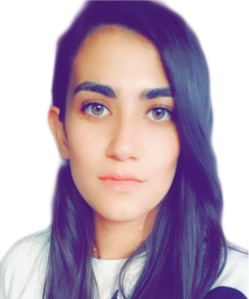
Pascale el Sayed
Sheikh Othman Street
Anouth
Lebanon
Phone: 0096176395695 E-mail: pascalesayed@gmail.com
__________________________________________________________________________________
A recent graduate with a degree in general business and management from USJ Beyrourh, my objective is to obtain a postion that will effectivly utilize my skills and to gain a new experience. As well, I am currently working on my masters degree also at USJ Beyrouth.
Education.
2016 – 2019: Saint Joseph University
BA in business and management
2013 – 2016: Lycee Pascal, Anouth
Lebanese Baccalaureate, LS

Professional experience.
Summer of 2019: Trainee at Lycée Pascal - accounting department, Anouth.
Summer of 2018: Trainee at BLC BANK, Saida.
Summer of 2017: Trainee at Lycée Pascal - accounting department, Anouth.
Skills.
IT: Word, Excel, Access, PowerPoint and Internet.
Languages: Arabic: fluent spoken, read and written
English: advanced
French: basic
Soft skills: Leadership, Communication, Team-building, Organizational, Decision
Making.

References.
Mohamad ghandour
Branch manager
BLC BANK, Saida.
Telephone: 07-722330

Dina Sidani
Campus manager
University of Saint Joseph, Saida.
Telephone: 07-731284

Mohamed El Sayed
School Manager
Lycée Pascal
Telephone: 03-218001

