Mira Hassan Kobeissi
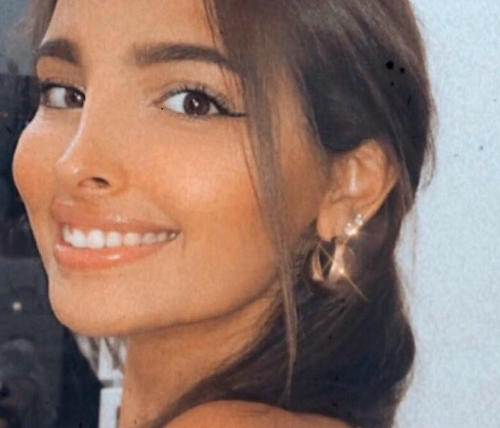
Address: AlMazraa 929 Block A, Omar Ben el Khattab st. Ras el nabeh, Beirut, Lebanon.
Phone number: +96171157879
E-Mail: mira.koubeissi@lau.edu
Nationality: Lebanese
Place of Birth: Beyrouth, Lebanon
Date of birth:11/08/1997
Marital status: single

Objective
Seeking a position in a progressive corporation where my skills and education can be effectively and efficiently utilized and advanced. My desire is to achieve results that will demonstrate my work success and enhance my personal growth. I have the passion of working in Media and reporting fields.

Experience

Volunteer for the Beirut Marathon: 2011
Greenfield college, Beirut

Event organizer: 2011-2014
Greenfield college, Beirut: across the school academic years contributed in ceremonies, graduation, prom, and plays.
Internships:
2016-2018
Writer at LAU mosaic newspaper
2017
Media executive at MTV Lebanon Station for a full month
2017-2018
LAU – Journalism club vice president
2018
Reporter at NBN Station for two full months
News room at NewTv Station for a full month
2019
Reporter at NBN tv station for four full months (August – December), and still Present

Education

Greenfield College, Beirut 2008-2014
Life science graduate (French educated)

Lebanese American University (LAU), Beirut 2015-2019
Multimedia journalism graduate
Achievements:

- Personal blog on Word Press and Medium: https://mirakoubeissiblog.wordpress.com/ & https://medium.com/@mirahkoubeissi (2014 - present).
- Interview with the General security directorate Major-General Abbas Ibrahim (2015).
https://mirakoubeissiblog.wordpress.com/2017/01/03/%d9%85%d9%82%d8%a7%d8%a8%d9%84%d8%a9-%d9%85%d8%b9-%d8%a7%d9%84%d9%85%d8%af%d9%8a%d8%b1-%d8%a7%d9%84%d8%b9%d8%a7%d9%85-%d9%84%d9%84%d8%a7%d9%85%d9%86-%d8%a7%d9%84%d8%b9%d8%a7%d9%85-%d8%a7%d9%84%d9%84/
- LAU-Best civic engagement project in Multimedia Journalism (2018).
- Directed and acted in a video story by me and my colleagues about Lebanese weddings, available on youtube https://www.youtube.com/watch?v=pY41tYVw98U (2018).
- Produced and directed a short movie related to Pre-teens and Facebook, available on Youtube on the following link https://www.youtube.com/watch?v=flAlhUEWJFs (2017).
- Investigation about beggars in Lebanon, readable on Wordpress.(2016) .
- Covered the opening of the 60th session of the Beirut Book Fair, readable on Wordpress (2016).
- Covered a Seminar on the proposed child protection law from early marriage, readable on Wordpress (2016).
- Article about Seagulls problem in Beirut Rafic Harriri international airport, readable on Medium(2016).

Skills
- National Political knowledge base (History, names, positions, …).
- PR, social media, and advertising skills (learned throughout the courses).
- Teamwork and leadership skills based on different workshops.
- Written and Oral communication skills (Arabic, French, English).
- Technological skills (Fifo, audacity, Podcasting, Video making, Adobe applications, Usage of Microsoft Office & Google Docs, …) in addition to multimedia storytelling skills.
- Acute sense of timing

