Curriculum Vitae
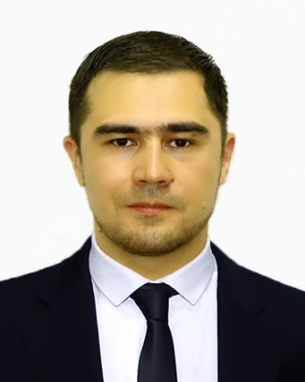
Current Address: Uzbekistan - Tashkent
Phone number: 00998 97 4486848
E-mail: contact@ravuss.com
What’s app: 00998 97 4486848

Personal Information:

Name Surname: Bakhtiyor Akhmedov
Date of birth: 2nd January 1983 (36)
Nationality: Uzbekistan
Spoken languages: English, Russian, Uzbek
Passport expiry day: 15.04.2023
Driving License: UAE, Uzbekistan (19 years driving experience)

About myself & Career objectives:

I'm married. I have three children. My goal is to get a permanent job in a good company, in order to build a good future for my children in the future. I'm looking forward to be a part of company, which provides opportunities for growth and advancement, where by using my experience, knowledge, capabilities and abilities I will successfully contribute to the growth of the company.
I sincerely hope not to disappoint and justify your trust in me.

Key Skills and Competencies:

- Communication skills with both customers and staff.
- Ability to work both as a team and individually.
- Strong decision making and problem solving skills.
- Able to motivate and lead others in a team environment.
- An ability to build rapport and trust quickly with work colleagues.
- Able to priorities tasks and workloads in order of importance.
- Track record of delivering results with deadlines.
- The ability to make the client feel welcome.

Education:

University of Economics - Bachelor of Economic Relations (Uzbekistan) 2001 – 2005.

Linguistic High School №178 (Uzbekistan) 1989 – 2001.

Trainings:

- Executive Service Training.
- Team Leader Training
- Computer courses.
- Telephone Techniques Training.

Work experience over the past 12 years:

Position: Manager
Period: July 2018 – present
Company: Clothing store “Tchibo”. Tashkent, Uzbekistan

Responsibilities:
- Monitor the progress of store advertising on the Internet.
- Monitor staff work and training.
- Set tasks correctly for staff.
- Properly motivate staff.
- Monitor the performance of staff tasks.
- Improve the work of staff, direct their efforts in the right direction.

Position: Manager
Period: January 2016 – June 2018
Company: Advertising agency “Ravuss”. Tashkent, Uzbekistan

Responsibilities:
- Keep track of customer database growth.
- Follow the advertising and promotion of the company.
- Think over strategies to achieve optimal results.
- To think over ways of development of the company. Based on the goals set, ways to achieve them will be developed.
- Correctly set tasks for subordinates.
- Monitor the execution of tasks.

Position: Property Consultant
Period: November 2013 – November 2015
Company: Real Estate agency “Propertyssimo”. Dubai, UAE

Responsibilities:
- Search for customers and for real estate.
- Provide clients with proposals for the purchase or rental of real estate.
- Act as an intermediary in negotiations between buyers and sellers.
- Compare our property database with similar properties sold to determine its competitive market price.
- Advising clients on all matters related to real estate.
- Promote real estate sales through all possible resources.
- Accompany clients while visiting and inspecting the property, advising them on the suitability and cost of the houses they visit.

Position: Senior of department
Period: September 2010 – October 2013
Company: Supermarket “Korzinka”. Uzbekistan, Tashkent

Responsibilities:
- Provide a good level of customer service.
- Monitor staff so that they greet customers with a smile, guide them and help them make a choice.
- Check availability and quality of goods.
- Сount the leftovers and make an order of the necessary products.

Position: Sales person
Period: September 2008 – July 2010
Company: Boutique “Europa Exclusive”, Uzbekistan, Tashkent

Responsibilities:
- Greet customers by providing good service.
- Guide customers to racks and counters offering items.
- Advise customers by providing product information.
- Helping customers make choices by building customer confidence.
- Keep order throughout the store.

All information is reliable. Upon request, the workbook (employment history) can be notarized into any language.

