hello!! I am
Rania Khoury
University Instructor
Graphic Designer
Visual Artist

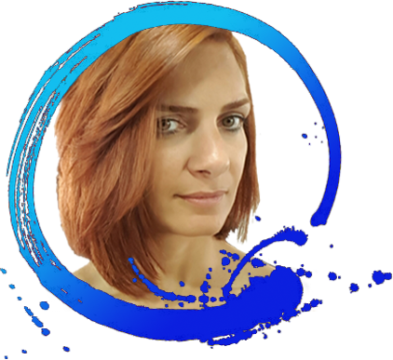

Bayada, Str#8, Bldg#11, floor#2
Beirut, Lebanon
+961 3 634196
rania_rk@hotmail.com

Education Qualification
Masters Degree - Graphic Design and Visual Communications
ranked THIRD among my promotion
Institut Des Beaux Arts (LU)
March 2011 - 2013
Furn El Chebbak – Lebanon.
BS program - Psychology
Lebanese University (LU)
July 2003 - October 2004
Fanar – Lebanon
BA - Graphic Design
Notre Dame University (NDU)
October 1997 - July 2000
Zouk Mosbeh – Lebanon
AAS - Advertising Design
graduated with HONORS
Lebanese American University (LAU)
October 1995 - July 1997
Byblos - Lebanon
School - Sainte Famille Fanar
Fanar – Lebanon

Experience in teaching practical and theoretical courses, for POSTGRADUATE and UNDERGRADUATE programs, since 2014

• Photoshop
• Illustrator
• Fundamentals of Design
• Theory of Colors
• Storyboard
• Graphic Design Studio
• Rendering & Illustration
• Semiology
• History of Art
• History of Graphic Design
• History of Design

Other Experiences in teaching since 1995

• SABIS International School • 2005 till 2008 | • Art and Crafts PK to G12
• Private lessons • 2002 till now | • Design Software  • Art and Crafts  • Drawing and Perspective
• Assistantship at LAU • 1995 till 1997 | • Airbrush classes  • Basics of drawing classes  • Rendering classes

Employment
• I worked as an administrative support for LIFE, a NGO which nurtures the studies of the upcoming Lebanese generation all around the world - From June till December 2018
• Art Director at BrowsArsabia s.a.l. - 2001 till 2002

Freelancing Designs since 1999
My projects have covered myriad kinds of artwork for reputable clients and companies, such...

• Logos and Stationeries: St Paul Cathedral Harissa, Dr Toni Nassar Brazil, Armouti Auditing CPA Jordan, ISASC s.a.l. (Lebanon, Egypt & USA), Zumuruda Kuwait.
• Brochures and portfolios: SILVER, Smart Blocks, ISASC s.a.l. (Lebanon, Egypt & USA).
• Big event greeting cards: Prince Aziz Ben Abdel Aziz Ben Saoud -KSA, La Carterie, Netways.
• Illustrations: Dar El Moufid, Lebanese academic books, Tania Savelieff – Russia.
• Paintings: Depute Hagop Hagopian, other private owners.
• Book covers: Clarion Publishing House, Goldene Geschichten, Our Daily Bread.
• Packaging: Yummy Yummies, Cotton Candy, “Probio 7” supplements.
• Menus: Lulu’s Pizza Australia, Awtar restaurant, The Sheriff, Le Café.
• Billboards, Unipoles & Posters: Priotic Plus, Sensuelle, Dandy, The Leisure Club.
• Magazine ads: Sensuelle, Browsarabia s.a.l., Megreetings.com, Barternet s.a.l.
• Family trees and graphs: Âl Soussa, Âl Bakar.
• Styrofoam sculpting: Bébés Câlins, Sugar Mooch, Clapping Hands.
• Promotional items, games & monuments: Lebanese Red Cross.
• e-Banners: Monroe Hotel, Librairie Antoine, Vanlian, Bonja, Citroen.
• Websites: Doueihi Sweets, Pascale Mechalani.
Do you want to know more about me?

I have computer literacy

I have skills
• Styrofoam sculpting
• Art crafts
• Paper Engineering
• Creative Packaging
• Painting
• Illustration

My work has featured on TV channels, in magazines and websites:
• LBCI “Marti W Ana” | •• MTV “Chou Fi Jdid” | • • MTV “@MTV” | • • FUTURE "Mega"
• ORBIT "Ioun Beirut" | •• LBCI "Naharkon Said” | • • NBN | • • ORBIT "Internet Magazine»

• L’Orient Le Jour | • Dar Almoufid Catalog | • LAU Calendar | • UniverCity Issue
• Today’s Outlook | • Bizut | • Echo Magazine | • Netways eNews
• L’Hebo Magazine | • L’Orient Le Jour | • Echo Generation
I have earned certificates in
• Teaching Style
• Leadership & Coaching

I won prizes in art
Won Fabriano prizes in 1994 • 1995 • 1996

I am very sporty and won medals as well
• Swimming • Gymnastic • Judo

I was affiliated to
• Lebanese Red Cross in the rescue team
• Scouts Du Liban

I have hobbies
• Traveling and I have traveled a lot thus far
• Reading
• Photography
• Arts & crafts

I speak languages
• English  • French  • Arabic  • German  • Japanese | 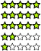

… and if you want to know more, I can provide you with references.

