PAULINE GEORGES DABAGHI  .Email : paulinealdabaghi@outlook.com  .Date of birth: 22-08-1990  .Marital status: Single  .Address : Beirut, Achrafieh, Karem Zaytoun | 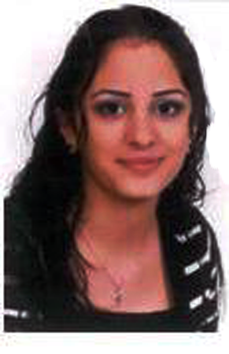

Career Objective

I have experienced working in customer service field.I have good communication skills to make good interaction with the customers .I’m capable for problem solving .Customer’s satisfaction is my orientation.

Education

. BT Accounting and Informatic | Sagesse high school
. TS Expert accounting and account revision | Sagesse Technical University (offecially graduated)
. LT Expert accounting and account revision |
Insutriel Technical University (IPNET)

Established and implemented administrative policies and procedures for the office.
Filed and recordedcorporate documentation, electronic files, inventories and reports.
Sorted and distributed incoming communication data, including faxes, letters and emails.
Monitored and maintained the organization’s website.
Interacted with organizational staff, executives, clients, vendors and visitors on a daily basis.
Organized the scheduling of meetings, conferences, and events; distributed minutes for them.
Coordinated agendas for meetings with visitors and clients– arranged guest and travel accommodations.
Took care of staff office space, weeklyschedules, travel reports, phones, creditcards and office keys.
Maintained the office database – retrieved and organized information for individual employees and clients.

. SGBL Bank Hr Receptionist | From : May 2018 till now
. Directs visitors by maintaining employee and department directories.
. Supports continuity among work teams by documenting and communicating actions, irregularities, and continuing needs.
. Contributes to team effort by accomplishing related results as needed.
. Carrying administrative duties such as filing, typing, copying, binding, scanning etc.

.BEMO Bank Adninistration Unit | From: 18 Dec 2014 till May 2018

. Processing invoices

. Preparing and distributing checks, handling cash and invoices, making phone calls, and basic bookkeeping
. Processing expenses sheets and invoices.
. Monitoring stationary levels and ordering office supplies.--. Replying to email, telephone or face to face enquiries.
. Resolve administrative problems.
. Coordinating repairs to office equipment.

.Event Coordinator and Social Media | Confex International From : 02 Jan till 30 Sep 2014

. Assist with sponsorship, research and speaker outreach

. Booking venues and schedule speakers

. Manage event stock material (brochures, roll-ups.. etc.)
. Setting up and optimizing company pages within each social media platform.

Special Skill

. General Math Skills, Accounting, Deadline-Oriented, Confidentiality, Coordination, Quality Focus, Objectivity..

. Attention to detail and high level of accuracy.

. Knowledge of office administration procedures.
. Managing multiple and changing priorities at once.
. Good computer skills including Word, Excel, MS Outlook, PowerPoint,Illustrator, Photoshop,Indesign…

. Good typing and keyboard skills.

Personal Information

.Languages :Arabic: Fluent (Read, Write, Speak)

French: Fluent (Read, Write, Speak)

English: Fluent (Read, Write, Speak)

.Hobbies:Sports,Reading and Research.

References

Hope this cv holds enough information about me for any additional infomation or references please contact me.

