‍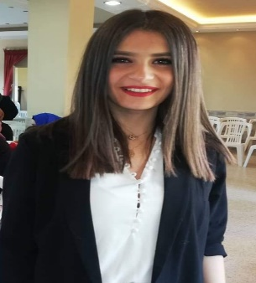
|Date of Birth: Sep 5, 1995
|Gender: Female
|Marital Status: Single
|Nationality: Lebanese.

‍Mirna Noureddine
Beirut-Lebanon | +961 71 004 389 | mirnanoureddine5@gmail.com |

- Education
Bachelor degree | (distinguished graduate) | Lebanese International university
- Major: International Business Management
International academy for building capacity (iabc)
- Social worker & life skills trainer certificate

- Professional Experience
english teacher | new vision education center – dier oubil, lebanon | feb 2017 - Present
- Combating Illiteracy by teaching students the basics in English

monitor | sabis school summer camp - beirut, lebanon | summer 2016
- Supervising the class students during activity time

sales assistant | nine west - beirut, lebanon | jun 2015 – sep 2016
- Customer Service and advisor
- Sales & cashier
cashier | bagels plus – beirut, lebanon | feb 2014 – oct 2014
- Cashier
sales & promotion | moustache – beirut, lebanon | jan 2013 – nov 2013
- Perfume promoter & sales
animator | fRizzy – beirut, lebanon | jun 2011 – mar 2013
- Taking care of kids, entertaining them and leading group activities

- Skills

Languages
- Arabic, Native Language
- English, Fluent
- French, Working Knowledge
Technical skills
- Knowledge in Microsoft Office & Internet Browsing
- Strong Communication Skills
- Skilled in time management & organization
- Skilled in Customer Orientation

- References
Available upon request.

