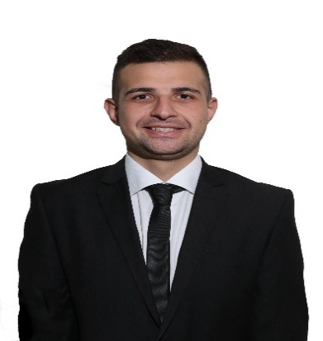
DAvid melki
Nationality: Lebanese
Address: Beirut, Lebanon
Phone number: +96170931325
Email: David.melki@live.com
Date of Birth: 16/09/1993

Objective
A motivated, friendly and enthusiastic individual with excellent communication and customer service skills seeking a challenging career environment where I can grow and gain more experience.

Experience
Urbanista, Lebanon
Restaurant Manager | June 2015 to May 2019
- Recruiting, training and supervising staff
- Handling customer enquiries and complaints
- Taking reservations
- Greeting and advising customers
- Problem solving
Maison M, Lebanon
Supervisor | April 2012 to May 2015
- Monitor customer Satisfaction
- Manage Inventory
- Ensure high food safety standards

Education
Middle East University, Lebanon
First year MBA in Business Management(2018-present)
Bachelor degree in Banking and Finance graduated with a GPA of 3.2

LANGUAGES: Fluent in English, Arabic and Armenian.
SKILLS: Flexibility and adaptability to adjust to a new environment, Emphatic and positive at all times.
OTHERS: First Aid Certificate from the Lebanese Red Cross in 2011.

