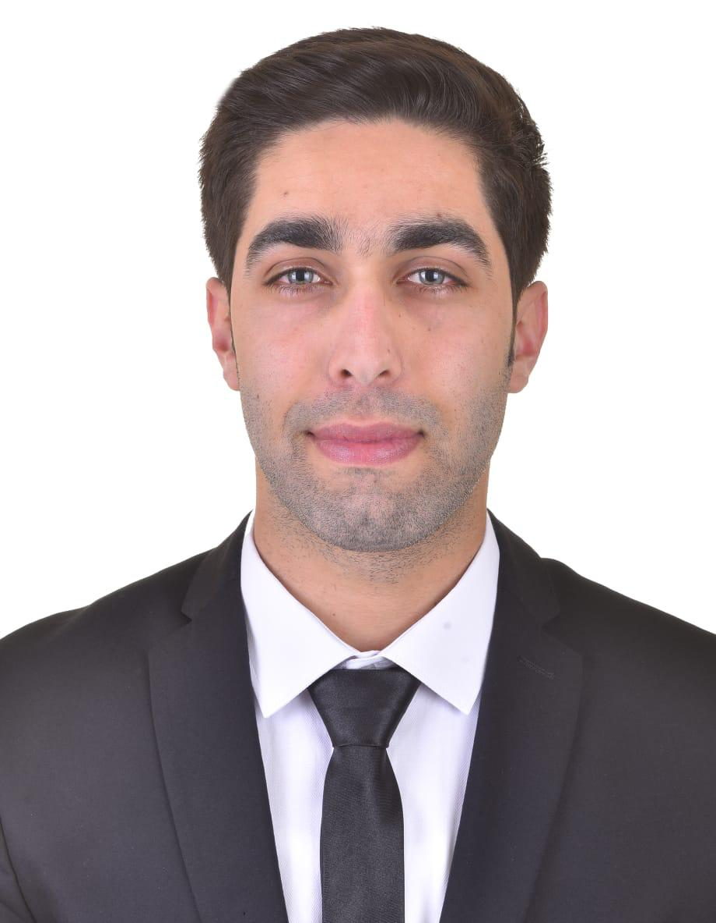 Hassan Mohamad Youssef
Tekrit-Akkar Al Daker street
Mobile: +96103199442.
E-mail: hassan.youssef94@hotmail.com

PERSONNAL INFORMATION

Date of Birth: 5- April -1994 Status: Single

Nationality: Lebanese Residence: Lebanon, Tekrit-Akkar

PROFESSIONAL QUALIFICATIONS

ACADEMIC EDUCATION

- 2008: Brevet
Al Ilm Wal Iman School - Akkar, lebanon.
  - 2011: Baccalaureate in Socio-Economic:
Al Ouyoun high school - Akkar, Lebanon.
  - 2013: first year (TS1) construction and public works and survey
Halba Technical Institute – Halba, Akkar.

  - 2014: second year (Ts2) construction and public works and survey Halba Technical Institute – Halba, Akkar.

PROFESSIONAL EXPERIENCE

- From 2011 – Present: computer fixer (software).
- Worked as photographer at Daleel Akkar for 2 months.
  - worked as reception assistant at Rotana Arjan Raouche – Beirut.
- Worked as Personal secretary with former deputy MP Misbah Ahdab for 1 Year.
  - work as photographer at The North life Magazine from January 2016 till now.

TRAINING

  - From 2011- 2014: having my own internet station.
  - Emergency medical technician certificate, basic pre-hospital emergency care training. (Lebanese Red Cross).
  - Training at George Saraf’s topography office.
  - Certificate of participation & achievement for completing the step to the world of photography.
  - Certificate of Construction contractor from CIS College – Tripoli.

PERSONAL SKILLS

- AutoCAD (2D,3D), Revit, land desktop and winbox.
- Ms Office: Word, Power Point, Excel and Project.
- Computer programming the all Windows (Xp, Vista, Seven7, Eight8).
- Able to use own initiative and work as part of a team, with good grasp of group work.
- Ability to work with people with different background.
- Excellent command in spoken and written Arabic and good command of English.

REFERENCES

- MP Misbah Ahdab: 03553379.

- Mr. Edgard Barbar: Manager of the North Life Magazine 71822234.

