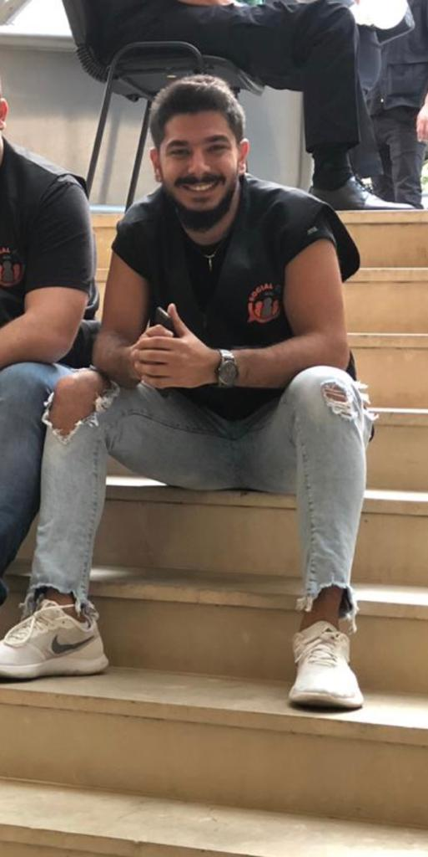 |  | stephan nazi
Profile  I am a third year computer science student at AUL kaslik university. I have developed excellent analytical and leadership skills through my degree., as well as key customer service and communication skills through my part time job at sofi de france in storiom saliba. I am a chief scout leader where I have gained the most wonderful experience in my life by learning how to communicate with all types of people and ages.  Birthday: 12 of April 1999.  Contact  PHONE:  +96176480595  EMAIL:  stephannazi@icloud.com  Hobbies  Camping  Hiking  Football |  | EDUCATION  -ANTONINE SISTER SCHOOLS IN GHAZIR 2002-2010  KG1 TILL GRADE 6  -DHOUR SHWEIR PUBLIC SECONDARY SCHOOL 2010 – 2017  GRADE 7 till grade 12  Graduated as a LIFE SCIENCE student.  -AUL KASLIK UNIVERSITY FIRST YEAR 2017-2018 GPA: 3.2  Learned: linear algebra / intro to computing / calculus 3 /English 203  Programming 1 C++ with lab / English 204 / electricity / discrete math  SECOND YEAR 2018-2019 GPA 3.1  Learned: programming 2 java with lab / probability and statistics /English (business and communication skills)  / Logic design with lab / advanced java with lab / numerical math / data structure with lab.  Third year: semester 1: database system / theory of computation / machine architecture and assembly  WORK EXPERIENCE  I worked as a sale manager for my father’s work which includes home appliances  I worked in zwazo company for a year which includes games for small kids and event handling  I worked in sofi de france in storiom O Plaisir with my university studies as a part time job.  I worked as a chef in lumberyard a chill place in beit chabeb.  SKILLS  I speak four languages: English, French, Arabic and German.  I am scouts for almost 12 years which made me a great leader by reaching a high position and learning how to socialize and talk to people of different ages.

