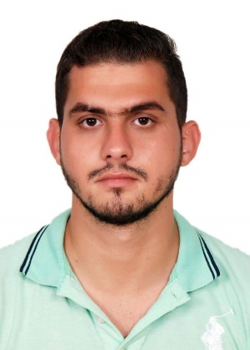
Rida Hussein Khafaja

- Nationality : Lebanese
- Date of Birth : 9th October 1990
- Phone : (+961) 71-237762
- E-mail : rida.176@hotmail.com
- Marital Status: Single
- Address : Bir-AlAbid / Beirut / Lebanon

PROFESSIOINAL OBJECTIVE

Seeking a position where I can use my educational background and professional skills in a dynamic organization, which promotes growth and advancements.

EDUCATION

-United Arab Emirates University
Bachelor Degree in Sales & Marketing
Al-Ain /Abu Dhabi / United Arab Emirates
Graduated in 2013-2014

-International English Institute For Language Studies
Certificate in Sat Test levels 1& 2
Certificate in Toefl Test
Certificate in Ielts Test
Al-Ain /Abu Dhabi / United Arab Emirates
Graduated in 2009-2010

- High School Al Adwa Privet School
American System
Al-Ain /Abu Dhabi / United Arab Emirates
Graduated in 2008-2009

-Al Sanawbar School
Al-Ain /Abu Dhabi / United Arab Emirates

WORK EXPERIENCE

-Warehouse Assistant & Sales
Nestle International Company
Dbayeh/Beirut/Lebanon
From 12/2016 to 05/2018
-Sales
American House Hold
Jnah/Beirut/Lebanon
From 05/2015 to 11/2016

-Sales & Marketing
One To One Hotel
Al-Ain/Abu Dhabi/United Arab Emirates
From 02/2012 to 08/2013

-Customer Service And Survery
Daman Health Company
Al-Ain/Abu Dhabi/United Arab Emirates
From 08/2010 to 10/2011

2008-2009: High School Al Adwa Privet School (American System).
2013-2014: Al Khwarizmi International College basholr degree in sales&markting
Master 1 in sales &marketing

SKILLS

Language: Fluent in Arabic and English.

Computer skills: Microsoft Office (Word, Excel, PPT, Access, Project) and Internet research.

Personal traits: Ambitious, dynamic person, team player and fast learner.

Hobbies: Traveling, swimming, playing football and biking.

Others:

- Valid international License.
- Excellent customer service.
- Excellent interpersonal and communication skills.
- Strong organizational and time-management abilities.
- Able to work both independently and in a team environment.
- Self-motivated, hardworking, reliable, and conscientious.
- Willing to learn and implement new skills and procedures.
- Work well under pressure in a busy environment.
- Experience in Quality Control, teaching and development of new system.

